UPlan Reference Guide:
Tuition and Fee Revenue Calculator

© [2013-2014] “University of California San Francisco (UCSF)”
Ownership of Copyright
The copyright in this material (including without limitation the text, artwork, photographs, and images) are owned by UCSF.
Copyright License
UCSF grants to you a non-exclusive royalty-free revocable license to:
- View this material on a computer
- Store this course in your cache or memory
- Print pages or material from this course for your own personal and non-commercial use
All rights reserved.
Enforcement of Copyright
UCSF takes the protection of its copyright very seriously. If UCSF discovers that copyrighted materials have been used in contravention of the license above, UCSF may bring legal proceedings against you seeking monetary damages and an injunction to stop you from using the materials.

Reference Guide: Tuition and Fee Revenue Calculator
This reference guide discusses the Tuition and Fee Calculator in the General Planning module.

Reference Guide Objectives
This document is intended to enable planners to:
- Understand the model for recording tuition revenue and transfers
- Explain the purpose of the Tuition and Fee Revenue Calculator
- Enter or adjust revenue drivers on the calculator
- Grasp the limitations of spreading capability on the calculator and the ways to address them
- Generate reports displaying tuition and fee revenue plans
- Plan tuition and fee revenue transfers

Tuition and Fee Funds in PeopleSoft
Actual tuition and fee revenue is identified in several ways in the PeopleSoft General Ledger.

Fund
There are 11 funds that identify tuition and fees.
Fund Number | Label
3000 | Tuition
3010 | Nonresident Tuition
3020 | Summer sessions
3030 | Prof degree tuition, medical
3040 | Prof degree tuition, dentistry
3050 | Prof degree tuition, nursing
3060 | Prof degree tuition, pharmacy
3070 | Misc professional fees
3080 | Other student programs (self-supporting programs)
3100 | Student services fee
3110 | Other student fees

Project
Control points or departments that generate Tuition and fee revenue may use the general undesignated project (Project 1111111) or a specific designated Project to record program revenue and expenses.

Account
The Account tree includes a series of posting-level accounts for recording tuition and fee revenue by the type of tuition or fee and by term. When tuition and fee revenue is generated, it should be recorded in one of the tuition and fee revenue accounts (40001 through 40404). These accounts should be used by the unit that initially generates the tuition and fee revenue.
The account for identifying tuition and fee revenue transfers is 74400. This transfer account should be used when the unit that originally generated the tuition and fee revenue is transferring the funds to another unit.
The revenue accounts and the transfer account roll up to the same Level C Account in the Account tree.
Note: The use of Fund and Account should correspond when revenue is recorded. For example, revenue for Fund 3040: Prof degree tuition, dentistry should be recorded in one of the accounts under 4302E: Differential fee – professional school.

Level C | Level E |  |  | Level F Posting-Level Accounts
4300C Student tuition & fees |  | 4300E | Tuition - nonresident | 40001 | Nonresid suppl tuition-fall
 |  |  |  | 40002 | Nonresid suppl tuition-winter
 |  |  |  | 40003 | Nonresid suppl tuition-spring
 |  | 4301E | Tuition/fees - mandatory | 40101 | Tuition/fees-mandatory-fall
 |  |  |  | 40102 | Tuition/fees-mandatory-winter
 |  |  |  | 40103 | Tuition/fees-mandatory-spring
 |  |  |  | 40104 | Tuition/fees-mandatory-summer
 |  | 4302E | Differential fee - prof school | 40201 | Professl school fee diff-fall
 |  |  |  | 40202 | Professl school fee diff-winter
 |  |  |  | 40203 | Professl school fee diff-spring
 |  |  |  | 40204 | Professl school fee diff-summer
 |  | 4303E | Self-support programs | 40301 | Self-support prog fee-fall
 |  |  |  | 40302 | Self-support prog fee-winter
 |  |  |  | 40303 | Self-support prog fee-spring
 |  |  |  | 40304 | Self-support prog fee-summer
 |  | 4304E | Student tuition & fees (other) | 40401 | Application for admission
 |  |  |  | 40402 | Student fees - other
 |  |  |  | 40403 | Fee exemption-veterans
 |  |  |  | 40404 | Student tuition/fee write-offs
 |  | 4305E | Transfer tuition & fees | 74400 | Tfr - tuition and fees

Tuition and Fee Funds in UPlan

Fund and Project
All tuition and fee funds are available for planning in UPlan. There are also no differences for UPlan handling of the Project dimension as it relates to tuition and fee funds.

Account
On the UPlan General Planning Revenue and Expense form, two accounts are identified as planned revenue and operating revenue transfers of tuition and fee funds:
- Level C Account 4300C is used for planning tuition and fee revenue as it is received by the generating unit. This row will be gray for the forecast and plan months, and will be populated based on the data entered in the Tuition and Fee Revenue Calculator form.
- Tfr – Tuition and Fee is used for operating revenue transfers of tuition and fee funds planned in the Commitment Tracking module
Note that both actual revenues and actual transfers will appear in the Level C Account row.

Tuition and Fee Revenue Calculator Form
The UPlan Tuition and Fee Revenue Calculator form provides planners with a way to calculate and adjust their tuition and fee revenue based on planned enrollments and tuition/fee levels, thereby keeping a record of the drivers that planners used in generating their revenue estimates.
The form allows for tuition and fee revenue to be calculated using two separate tuition/fee levels and in addition allows for a lump sum adjustment to total revenue.
For each of the tuition rates, the revenue amount is calculated as follows:
Revenue = (Enrollment – Enrollment Waivers) * Tuition Level
The Tuition and Fee Calculator Form is structurally similar to the Revenue and Expense form.

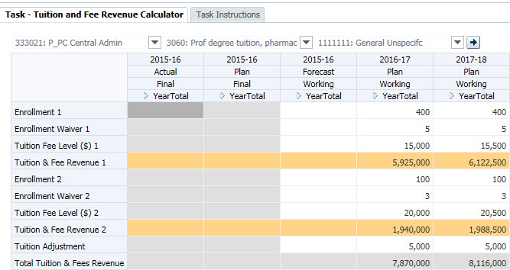

Page Filters and Columns
The Page Filters include DeptID, Fund and Project. Fund choices are limited to the 11 tuition and fee funds. In addition, the columns contain the same Scenario, Version, Year, and Period options that are found on the Revenue and Expense form.

Rows
Row | Row Label | Usage
1 | Enrollment 1 | The planned total number of students enrolled for the first tuition revenue calculation.
2 | Waiver 1 | The planned number of enrolled students who are eligible for tuition/fee waivers for the first tuition revenue calculation
3 | Tuition Fee Level 1 | The level of tuition (tuition rate) for the first tuition revenue calculation.
4 | Revenue 1 | Revenue from tuition level 1, calculated as the tuition level multiplied by the enrollment level 1 less enrollment waivers 1.
5 | Enrollment 2 | The planned total number of students enrolled for the second tuition revenue calculation.
6 | Waiver 2 | The planned number of enrolled students who are eligible for tuition/fee waivers for the second tuition revenue calculation
7 | Tuition Fee Level 2 | The level of tuition (tuition rate) for the second tuition revenue calculation.
8 | Revenue 2 | Revenue from tuition level 1, calculated as the tuition level multiplied by the enrollment level 2 less enrollment waivers 2.
9 | Adjustment | This field is available for making an adjustment to the total revenue amount for the DFP combination. The adjustment should be a dollar amount.
10 | Total Revenue | The total revenue amount for the DFP, calculated as the sum of the two individually calculated revenue amounts and the adjustment amount.
The rows on the Tuition and Fee Revenue Calculator form are different. Instead of the revenue and expense accounts that appear on the Revenue and expense form, it has rows for enrollment, tuition waivers, tuition rates, and adjustment value, and calculated amounts.

Spreading on the Tuition and Fee Revenue Calculator
In order to ensure that revenue amounts are calculated correctly, spreading of values from YearTotal to Months is only enabled for the Tuition Fee Level rows and the Adjustment row. Thus, a Tuition/Fee revenue amount entered in the YearTotal column will spread evenly to the 12 months of the year. An adjustment entered in the YearTotal column will be treated similarly.
Enrollment and Waiver values entered in the YearTotal column will not spread, but instead will “fill” – that is, the same value will be entered in each of the monthly cells. In this way, the form assumes that enrollment is constant over the course of the year, and tuition/fee amounts are paid proportionally by students over the course of the year.

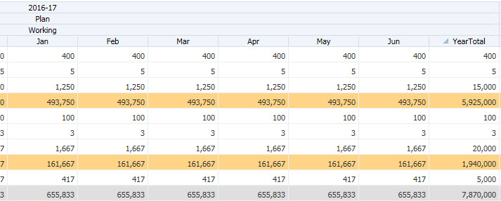

Adjusting Row Spreading on the Tuition and Fee Revenue Calculator
The first time data are entered into the YearTotal column for Enrollment and Enrollment waiver rows, the monthly cells will fill with the value entered. Subsequent adjustments to the YearTotal column will not fill all of the monthly cells, but instead will only adjust the value for June.
In the screenshot below, the YearTotal value for Enrollment 1 has been changed from 400 to 600 and the YearTotal value for Enrollment Waiver 1 has been changed 25 to 10. However, these new values have only spread to the June period.
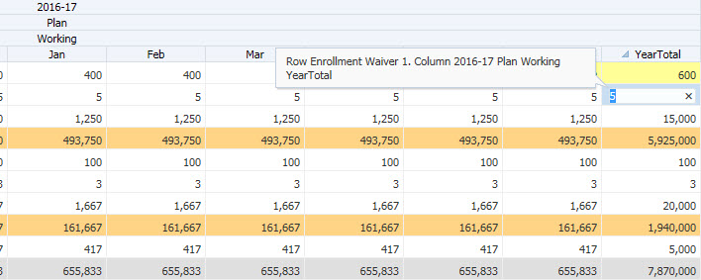

To adjust row spreading on the Tuition and Fee Revenue Calculator:
- Right-click on the row and choose Adjust then Grid Spread.
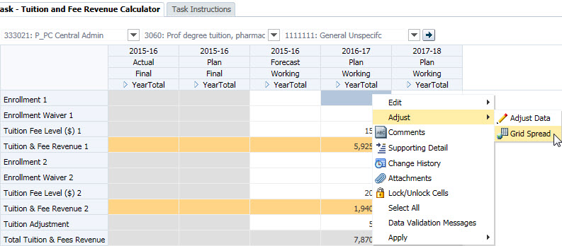
- In the Grid Spread pop-up box, change the Spread Value to “0” and choose “Fill” and Spread.
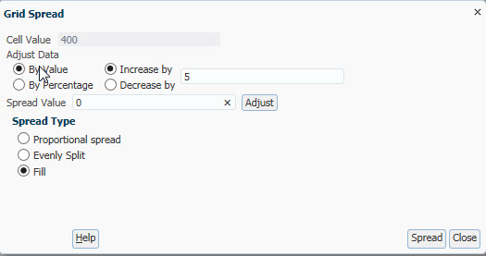
The row has now been re-set, and spreading will fill correctly using the YearTotal column.

Tuition and Fee Revenue Calculator Reports
UPlan includes two Form Reports specifically for reviewing tuition and fee revenue plans.
The Tuition Revenue by Selected DFP report shows the YearTotal values for each element of the calculated revenue total for a selected DeptID – Fund – Project combination. Rows are displayed for each Scenario, Version, and Year in the system.
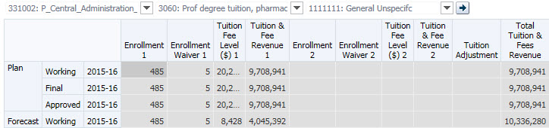
The Tuition Revenue by Selected Year and Scenario report shows the YearTotal values for each element of the calculated revenue total for a selected Scenario – Version – Year combination. Rows are display for each DFP combination in the designated MyOrg.
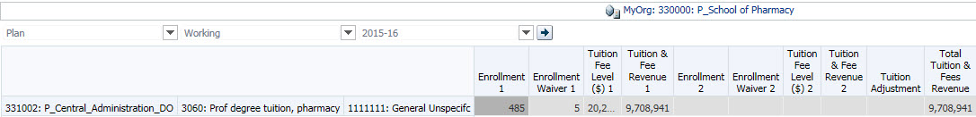

Planning Transfers in Commitment Tracking
As described above, planners in units that initially generate tuition and fee funds should record that revenue using the Tuition and Fee Revenue Calculator. Then, if they transfer any of their tuition and fee funds to other units, they should use the Commitment Tracking module to plan those transfers. We encourage planners to use a single commitment with multiple distributions to plan all of their tuition and fee transfers. Similar to the handling of the State Educational Appropriation, departments generating tuition and fee funds may want to use cascading commitments to transfer funds.

Operating (Above the Line) Transfers
Transfers that represent the movement of operating funds (as opposed to dean’s support or other temporary subsidies) should be recorded with the “Allocations and Other Operating Transfers” Transfer Type member. In these cases, when combined with a tuition or fee fund number, the planned transfer will appear on the “Tfr Tuition_C” or “Tfr Tuition_E” line of the General Planning Revenue and Expense form. For actual transfers in PeopleSoft, analysts should use Account 74xxx Tuition and Fee Transfers.

Planning Transfers to the Financial Aid Office
Specifically, units that generate Professional Degree Supplemental Tuition (PDST) should plan a transfer in the Commitment Tracking module to provide the Financial Aid Office with the appropriate share of PDST funds for financial aid. Use the following fields to plan transfers to the Financial Aid Office, based on your program:
Field | Member
Target DeptID | 472118 E_SFA Awards - Dentistry  472119 E_SFA Awards - Medicine  472120 E_SFA Awards - Nursing  472121 E_SFA Awards - Pharmacy  472122 E_SFA Awards - Dental Hygiene  472123 E_SFA Awards - Phys Therapy  472125 E_SFA Awards - Dent Post Grad  472141 E_SFA Awards - Translational Med
Target Project | 1111111 General unspecified
Transfer Type | Allocations and Other Operating Transfers
Approval Date | Any valid date
For financial aid funded from Tuition, Student Service Fees or any other centrally-managed source, Budget and Resource Management will manage commitments as follows:
- Professional student financial aid: Target DeptID 472117 “E_SFA Awards – General”, Target Project 1111111
- Graduate student financial aid: Target DeptID 471071 “E_Grad Stdt Support”, Target Project 2001951
With respect to spreading these commitments across months for Year 0 and Year 1, transfer amounts should be entered in a way that reflects the way actual transfers in PeopleSoft will occur. If transfer journals will be submitted to PeopleSoft on a quarterly basis, then the planned commitment in the Commitment Tracking module should reflect that pattern.

Non-operating (Below the Line) Transfers
Transfers that represent non-operating support (such as dean’s support or other temporary subsidies) should be recorded with the appropriate Transfer Type member. In these cases, the planned transfer will appear in the Other Changes of the General Planning Revenue and Expense form. For actual transfers in PeopleSoft, analysts should use the appropriate Level F Account from the Other Changes section of the Account tree.

