© [2015-2016] “University of California San Francisco (UCSF)”
Ownership of Copyright
The copyright in this material (including without limitation the text, artwork, photographs, and images) are owned by UCSF.
Copyright License
UCSF grants to you a non-exclusive royalty-free revocable license to:
- View this material on a computer
- Store this course in your cache or memory
- Print pages or material from this course for your own personal and non-commercial use.
All rights reserved.
Enforcement of Copyright
UCSF takes the protection of its copyright very seriously. If UCSF discovers that copyrighted materials have been used in contravention of the license above, UCSF may bring legal proceedings against you seeking monetary damages and an injunction to stop you from using the materials.
Contents
1.0 Employee Planning Overview 6
1.1 Employee Planning Features 6
Adjusting Salary and Benefits for Individual Employees 7
Adjusting Salary and Benefits for “To-be-hired” Employees 7
Funding for Salary and Benefits NIH Over-the-Cap 7
Employee Planning Business Process 8
What is Not Included in Employee Planning 8
Year 2 Salary and Benefits 8
Pay Components 9
Employee Type 9
Employee Planning Data Entry Forms 9
2.0 Individual Employee Forms 10
2.1 Search Individual Employees 10
Tab 1 Employee Salary 12
Tab 2 Employee Benefits 13
Tab 3 Pay Distributions 15
Adding and Deleting Distributions 15
Distribution Percentages 20
More than 100%? 20
Tab 4 Distributed Salary and Tab 5 Distributed Benefits 20
Tab 6 Employee Summary 21
2.2 Employee Landing Page 22
2.3 NIH Over-the-cap (OTC) Form 26
NIH OTC Form 27
3.0 Multi-Employee Forms 29
3.1 Multi-employee Salary and Benefit Level Form 29
3.2 Multi-employee Pay Distribution Form 30
4.0 To-Be-Hired Employee Forms 31
What is a TBH Provision? 31
Using TBH for Group Provisioning 32
4.1 TBH Landing Page Form 32
TBH Numbering 33
Base Salary Calculation for TBH Employees 33
Negative Provisions 33
Salary Distributions 34
Right-Click Menu Options 34
4.2 Search Individual TBH Form 38
5.0 Employee Planning Global Assumptions and Seeding 40
Salary Global Assumptions and To-be-Hired Provisions 42
Benefit Global Assumptions 42
5.1 Seeding in Employee Planning 43
Seeding Rules for Salary Levels 44
Seeding Rules for Benefit Rates 44
Seeding Rules for Pay Distributions 45
6.0 Faculty Portfolio and Employee Planning 52
Information for Units Using Faculty Portfolio 52
7.0 Employee Planning Form Reports 53
8.0 Other Employee Planning Topics 54
8.1 Handling Special Situations 55
Multiple Title Codes 55
Medical Center Employees 55
Benefits for Fellows and Residents with No Salary (pending changes) 55
8.2 Adjusting Planned Salary and Benefits in General Planning 56

1.0 Employee Planning Overview
This document discusses Employee Planning -- a UPlan module that enables detailed salary and benefit expense planning. Planners may plan for individual employees, groups of employees, and anticipated hires or reductions. (Note that throughout this manual, “planners” and “you” are used interchangeably.)
- Employee data feeds from the Payroll/Personnel System (PPS) and from Faculty Portfolio to avoid duplicative work.
- Control Points and Level 2 departments can adjust global assumptions for salary levels and benefit costs.
- Use Employee Planning for the Current Year forecast and Year 1 plan
- For each current employee, planners may:
  - Adjust salary rate levels and benefit rates by month
  - Distribute pay across department, fund and project sources by month
  - Identify sources of funds to cover salary over the NIH cap
- Planners can also create new hires or planned reductions, either as individuals or groups.

1.1 Employee Planning Features
If you are planning at the individual employee level, you have two primary tasks:
First, you can plan salary and benefit levels for individuals whose Salary Level Planning Department is one of your planning DeptIDs. What this means is that the individual’s PPS Home Department either is the same as or was mapped to one of your planning DeptIDs and therefore you have the ability to adjust the salary and benefit levels for this employee. In this case, we say that you “own” the employee.
Second, for any employee, you can plan a pay distribution if one of your planning DeptIDs provides funding to support that employee’s salary and benefits, either now or in the future. In this case, we refer to the planning DeptID as a Pay Distribution Department and we say that you “fund” the employee.
The UPlan Employee Planning module provides capability to address all of these situations.
Reminder: Because home departments may not be planning departments themselves, a process was established to map home departments to planning DeptIDs based on Control Point and department input. These planning DeptIDs have the ability to plan the salary levels for the employees will be referred to as the Salary Level Planning DeptID. Throughout this lesson, we will talk about employees owned or not owned by your salary-level planning DeptID.
Employee Planning was designed to give Control Points and their departments flexibility in planning their salary and benefit expenses. You can put as much or as little detail into employee planning as your Control Point directs.
- For detailed employee planning, you can identify each individual’s specific salary components, benefits, and distributions, including plans for salary increases by employee. This includes accounting for the NIH "over-the-cap” funding.
- Some Control Points may direct planners to just use “To-Be-Hired” forms to plan for salary increases for groups of employees.
- On the other end of the spectrum, it is possible to enter aggregated amounts for salary and benefit expenses by DeptID, Fund, and Project (DFP) within the General Planning module.
For most Control Points, planners will at least do some detailed employee planning, along with new-hire planning. Your Control Point will have more information for you on their requirements.
The Employee Planning module provides several features to facilitate comprehensive planning for salary and benefit expenses.

Adjusting Salary and Benefits for Individual Employees
Data entry forms are initially pre-populated with employee characteristics, salary levels, benefits rates, and DFP distributions from the prior fiscal year final plan at the start of every fiscal year and updated by planners over the course of the year. As the forecast months close, payroll actuals from PPS are loaded and overrides data in the now closed month. Additionally, the salary rate levels are trued up with PPS data and flow to the forecast open months. Planners have the option to then seed the Year 1 plan data as well as reseed portions of the forecast. If the user owns the employee, they can adjust the salary levels and benefit rates across three pay components, which are aggregated PPS DOS code groupings: base and negotiated salary, faculty bonuses and incentives, and additional salary. If the planner funds the employee, they can distribute salary and benefit costs by the pay component across DFP combinations.

Adjusting Salary and Benefits for “To-be-hired” Employees
Planners can create (or delete) provisions for planned new hires and negative provisions for salary savings due to separations. These provisions, known as To-Be-Hired (TBH) employees, may be individuals or groups and characteristics, such as title code, may or may not be specified.
Similar to current employees, for the forecast and Year 1 plan, planners have the ability to distribute salary and benefit costs for TBH employees across multiple DFP combinations.

Funding for Salary and Benefits NIH Over-the-Cap
For both existing and TBH employees, UPlan will identify salary amounts that are unfunded due to NIH salary caps and enable planners to distribute sources of support to cover the unfunded cost by non-NIH DFP(s). Note that this is an optional feature.

Employee Planning Business Process
As with General Planning and Commitment Tracking, there is no single, correct way to approach your forecasting and planning for Employee Planning. Each Control Point will have different guidelines for their planners. And, even within those guidelines, you have many options regarding the order of planning tasks. Here, we will assume that you are going to plan in detail for your existing and future employees.
The following graphic helps give you a visual perspective on Employee Planning. Each large block represents activities to be addressed. Notice there are no arrows connecting these blocks. This indicates that you are not required to proceed in the exact order.
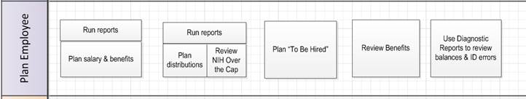
Initially, you may want to use Employee Planning reports within UPlan (such as the Compensation Detail by DFP report) to check the current state of forecast and plans for existing employees. These will help you determine which individuals’ compensation forecast or plans you need to update. You can start with current employees in your own department, current employees in other departments for whom you provide funding, or TBH employees. You can also review and adjust benefit rate information for the three pay components. Finally, after you complete updates to forecasts or plans, you can review diagnostic reports to check balances and look for errors.

What is Not Included in Employee Planning
All planning will be based on total salary for each month. Employee Planning does not include functionality for planning hourly pay. In addition, Employee Planning also does not address bi-weekly pay dates or hire anniversary dates (identifying merit or end dates).
Planners will need to track salary cap funding for non-NIH projects manually. These salary restrictions are unique to each award and usually stated in the contract. These are not currently tracked by any codes captured in Research Administration System (RAS).
Employees whose home department is the UCSF Medical Center are not included nor are distributions for campus employees who are with fully or partially funded by the Medical Center.

Year 2 Salary and Benefits
Within Employee Planning, planners will only be able to plan detailed salary levels, benefit levels, and payroll distributions for Year 0 (current year) and Year 1. Planners have the ability to seed the Year 2 salary level, benefits rates, and distributions based on the Year 1 values of a source month (e.g. values from June of Year 1). If any Year 2 salary and benefits global assumptions are entered, these will automatically apply upon seeding. The calculated distribution dollars will then flow to the Year 2 plan in General Planning.

Pay Components
An individual employee’s compensation may be comprised of many payroll components from the PPS system called Description of Service (DOS) codes that describe different types of pay. UPlan maps the majority of these DOS codes into three pay component groups for planning. This table provides an overview of the pay components. For more information, refer to the complete DOS Mappings in the UPlan Job Aid 206: Salary Component Definitions. (Note that throughout this manual, “pay component” and “salary component” are used interchangeably.)
Salary Component | Faculty Salary and Benefits | Non-Faculty Academic/Staff Salary and Benefits
Base and Negotiated | - Includes X and X' components of faculty salary (Health Sciences Compensation Plan) as well as credits that impact base pay.  - Includes Y component of faculty salary (Health Sciences Compensation Plan) | - Includes regular salary and those salaries that are treated like regular pay as well as credits that impact base pay.
Faculty Bonuses/  Incentives | - Includes only the BYZ portion of the Z component of faculty salary (Health Sciences Compensation Plan) | - n/a
Additional/  Other | - Includes all salary not included in the X, Y, and BYZ portion of Z components of faculty salary. | - Includes all non-base salary, such as shift differentials and overtime.

Employee Type
There are three Employee Types - Faculty Academic, Non-faculty Academic, and Staff Employee – that are based on title code. Salary and benefit expenses from Employee Planning will flow into General Planning into accounts depending on the employee type and pay component. For example, projected expenses for “Faculty Academic” and “Base and Negotiated” flow into Accounts “5000C: Faculty salaries_C” and “5030C: Faculty benefits_C”.

Employee Planning Data Entry Forms
Employee Planning includes three sets of planning forms along with reports and other functionality on the Task List.

Folder | Forms
Individual Employee Forms | - Search Individual Employees  - Employee Landing Page  - NIH OTC Forms
Multi-Employee Forms | - Multi-Employee Salary and Benefit Levels  - Multi-Employee Distribution Percentages
TBH Employee Forms | - Search Individual Employees  - TBH Employee Landing Page
Empl Global Assumptions | - Salary Global Assumptions  - Benefits Global Assumptions
Empl Seeding Options | - Forecast - Benefits Level  - Forecast - Distribution Pct %  - Year 1 - Salary Level  - Year 1 - Benefits Level  - Year 1 - Distribution Pct %  - Year 2 - Salary, Benefits, and Dist Pct %
Empl FP Feed | - FP Copy  - FP Restore Working
Empl Reports | - Compensation Detail by DFP  - Multi-Empl Distr Pct and $
Push Empl Data to General

2.0 Individual Employee Forms

2.1 Search Individual Employees
The Search Individual Employee form (also known as the Employee Composite form) allows data entry for a single employee. Planners can adjust salary levels, benefits rates, and pay distributions on this form.
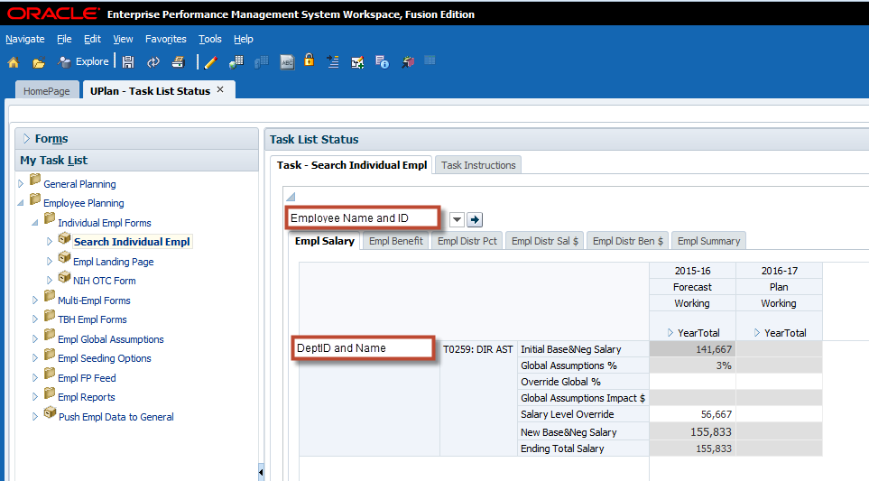
The Page drop-down Filter contains the Employee dimension. The form has six tabs for data entry and review, reducing the effort to load separate forms for different aspects of planning.
Tab | Label | Functionality
1 Employee Salary | Empl Salary | Updates to salary rate levels
2 Employee Benefits | Empl Benefits | Updates to benefits rates
3 Pay Distributions | Empl Distr Pct | Updates to pay distribution percentages
4 Distributed Salary | Empl Distr Sal $ | Review calculated salary dollar distributions
5 Distributed Benefits | Empl Distr Ben $ | Review calculated benefit dollar distributions
6 Employee Summary | Empl Summary | Updates to employee characteristics
Columns for Tab 1-5 include the Forecast scenario for the current year and Plan scenarios for Year 1 and all are expandable to months. The YearTotal for dollar value accounts sums July-June values whereas the YearTotal for percentage-value accounts reflects the last month that contains a value. For Tab 6, the summary data columns show prior year actuals, plan and forecast scenarios for the current year, and plan scenarios for Year 1; these columns are not expandable to months.
All tabs include title code and DeptID as rows. Other rows for pay component, fund and project may be included depending on the tab.

Tab 1 Employee Salary
Tab 1 (Empl Salary) allows planners to update the salary rate levels by pay component and re-calculates new values upon save. 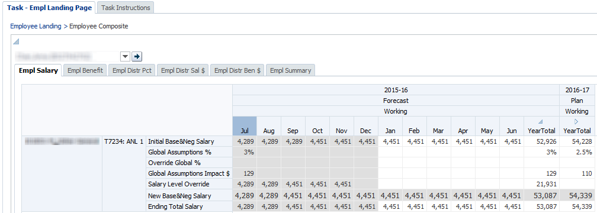
For Base and Negotiated salary, both the initial monthly salary and the global assumption are displayed. Planners can override the global assumption percentage with another percentage adjustment. Planners can also simply enter a new monthly salary amount, which takes precedence over the global assumption and the override percentages. As each forecast month closes, the Base and Negotiated salary is trued up with current data from PPS. The resulting ending salary is then shown, which carries forward as the initial salary in futures month as Base and Negotiated salary are considered recurring pay.
For two other pay components, Addtl Salary and Fac Bon&Incv (BYZ), planners simply enter the values in the relevant months. The values in these pay components do not carry forward to any future months as these are considered one-time or short-term pay.
The following table summarizes the rows on this tab:
Rows (Accounts) | Description
Initial Base&Neg Salary | Base and Negotiated Salary amount at the beginning of the period, before any salary adjustments are made
Global Assumptions % | Salary increase percentage based on the global assumption for the Title Unit Code to which the Employee belongs
Override Global % | Salary driver to override the global assumption for base and negotiated salary increase for this employee/title code combination
Global Assumptions Impact $ | Calculated dollar amount of the Global Assumptions % or the Override Global %
Salary Level Override | Base and negotiated salary level entered by planner to override initial base and negotiated salary amount and percentage increases. When a forecast month closes, this field is trued up with the salary level from PPS and carries forward to the next month.
New Base&Neg Salary | Ending base and negotiated salary calculated based on above salary driver accounts
Addtl Salary | “Catch-all” salary component that includes other DOS codes not applied to Base, Negotiated, or Faculty Bonuses and Incentives Salary. Examples include stipends and overtime.
Fac Bon&Incv (BYZ) | Faculty bonus and incentive amount based only on DOS code BYZ (part of the Z component of faculty salary under the Health Sciences Compensation Plan)
Non-UCSF Pay | Informational field to track salary paid from outside UCSF; does not affect plan or forecast
Ending Total Salary | The sum of New Base&Neg Salary, Addtl Salary, Fac Bon&Incv (BYZ), and Non-UCSF Pay.
Row suppression is applied so certain accounts may not appear. If needed accounts are not displayed, planners can right-click their mouse and select the Add Empl Salary Acct option to add rows with the account(s). Planners can also opt to delete a row for an account with no data by using the Remove Acct option on the right-click menu.
As shown in the example below, the new base and negotiated salary is calculated based on the four rows above it.
 | Row | Jul | Aug | Sep | Oct | Nov | Dec
(A) | Initial Base&Neg Salary | $100,000 | $100,000 | $104,000 | $104,000 | $110,000 | $110,000
(B) | Global Assumptions % |  | 3%
(C) | Override Global % |  | 4% |  | 5%
(D) | Salary Level Override |  |  |  | $110,000
(E) | New Base&Neg Salary | $100,000 | $104,000 | $104,000 | $110,000 | $110,000 | $110,000
 |  | (1) | (2) | (3) | (4)
- Because rows B, C and D are blank, the new salary equals the initial salary
- Row C takes precedence over Row B, and therefore the salary increases by 4%
- Note that the New Base&Neg salary for the prior month becomes the Initial Base&Neg Salary for the next month
- Row D takes precedence over Row C, and therefore the salary changes to $110,000

Tab 2 Employee Benefits
Tab 2 (Empl Benefits) allows planners to enter adjustments to the benefits rates by pay component and re-calculates new values upon save. For each pay component, the individual’s benefits rates are displayed where actuals appear in the closed months and prior year plan data appear in the open forecast months. Any relevant benefits global assumptions will appear on the form; these global assumptions are in addition to the individual benefit rate. For example, if an individual’s benefit rate is 25% and the global assumption is 5%, then the resulting adjusted rate is 30%.
Planners have the option to override these benefit rate percentages by pay component for each month. Planners should enter the new rate to the appropriate rate adjustment accounts (e.g. to adjust the Base&Neg Benefits %, enter the new rate to Base&Neg Benefits Adj %). Like the Empl Salary tab, row suppression is applied so certain accounts may not appear and can be added by selecting the Add Empl Ben Account via the right-click menu.
The form also displays the calculated benefits amounts based on either the original or adjusted benefits rates against the salary rate level for each pay component. Neither actuals nor planned overrides carry forward to future months; planners should enter overrides for all months as appropriate. 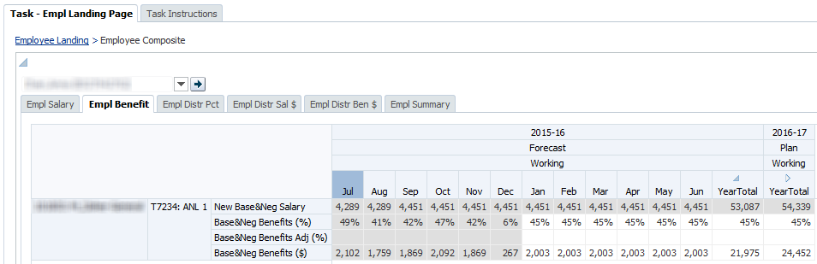
The following table describes the rows on the Employee Benefits form:
Rows (Accounts) | Description
New Base&Neg Salary | Ending base and negotiated salary from Employee Salary form
System-estimated Rate Accounts | Read-only
Base&Neg Benefits (%) | Seeded/calculated estimate of benefits rate for base and negotiated salary
Addtl Benefits (%) | Seeded/calculated estimate of benefits rate for additional salary
Fac Bon&Incv (BYZ) Benefits (%) | Seeded/calculated estimate of benefits rate for faculty bonus and incentive
Benefits Global Assumption Accounts | Read-only
Base&Neg Ben Incr % | Department-entered increase (or decrease) added to benefits rate for base and negotiated salary.
Addtl Ben Incr (%) | Department-entered increase (or decrease) added to benefits rate for additional salary
Fac Bon&Incv (BYZ) Ben Incr (%) | Department-entered increase (or decrease) added to benefits rate for faculty bonus and incentive
Rate Override Accounts | Writable
Base&Neg Benefits Adj (%) | Planner-entered override to benefits rate for base and negotiated salary
Addtl Benefits Adj (%) | Planner-entered override to benefits rate for additional salary
Fac Bon&Incv (BYZ) Benefits Adj (%) | Planner-entered override to benefits rate for faculty bonus and incentive
Dollar Amounts | Read-only
Base&Neg Benefits ($) | Dollar amount of benefits for base and negotiated salary
Addtl Benefits ($) | Dollar amount of benefits for additional salary
Fac Bon&Incv (BYZ) Benefits ($) | Dollar amount of benefits for faculty bonus and incentive

Tab 3 Pay Distributions
Tab 3 (Empl Distr Pct) allows adjustments to pay distributions by salary component. Rows include funding DeptID, Fund, and Project. All actual and planned DFP combinations are displayed. New DFP distribution line added in PPS will load to UPlan nightly, however, only the new DFP members will appear, not the percentage values from PPS. This allows planners ease of entering percentage data without adding a new DFP distribution row. Totals by title code and pay component are displayed at the bottom of the form.
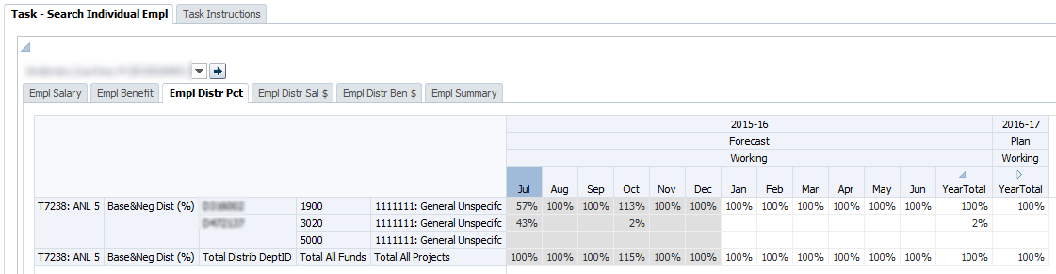
Values do not carry-forward from one month to the next, so planners must copy percentage adjustments to future months.
Write access is provided based on planner security settings. Planners may only add or adjust distributions for DeptIDs they own.
Since the accounts on the Employee Distributions form are all percent values, the YearTotal column will display the last non-missing value. This feature is known as the “time-balance-last” feature. For example, if June contains a percentage, the June value will appear in the YearTotal. If June does not contain a percentage, but May does, the YearTotal column will display the May value.
Additionally, the time-balance-last feature for percentage directs data entered in the YearTotal column to spread to all months if there is no data in any of the months. If data does exist in any of the months, then the percentage value entered will populate June only. Best Practice: Avoid entering data in the YearTotal column, unless you just added the DFP combination

Adding and Deleting Distributions
In some cases, you may need to add a funding distribution for an employee who is either owned by your department or owned by another department which your department funds. Note that planners can add a distribution for their DeptID(s), but cannot add or make adjustments to distributions for DeptIDs they do not control.

Where to Right-Click
You can right click anywhere in the form and select Add_ Dist to add a new distribution. Clicking on the right-most column for an existing distribution will pre-populate the form with the Title Code, Salary Component, and DFP combination you selected. In some cases, if there is only one change you need to make, this can be helpful.
To add a distribution:
- Right-click anywhere in the Empl Distr Pct tab workspace and select Add_Dist.
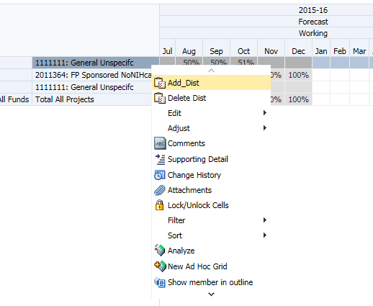
- The Add_Dist prompt will appear. To change a value, simply type in the value in the appropriate field or search by clicking the Member Selection pull-down icon to the far right.
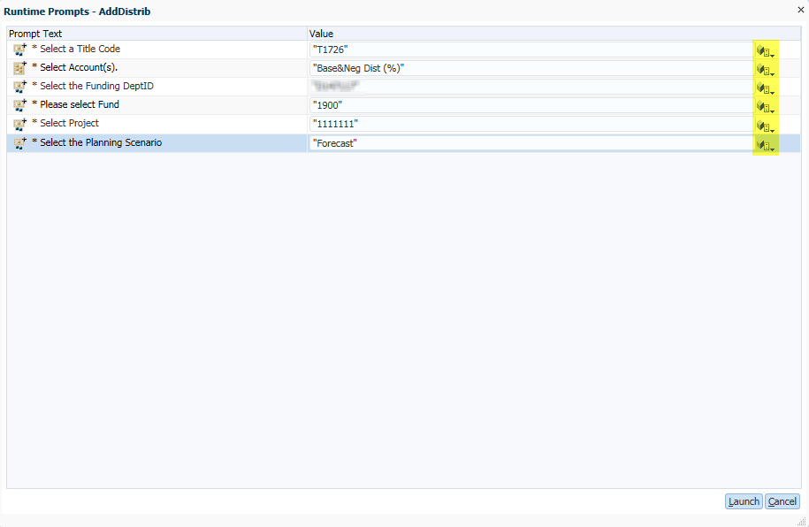
- If employee has more than one Title Code, insure that the correct title code is selected. Otherwise, click on the member selection pull-down icon to search for the correct title code. *Tip – the title codes usually shown in the row on the distribution tab so there is usually little need to search for the title code.
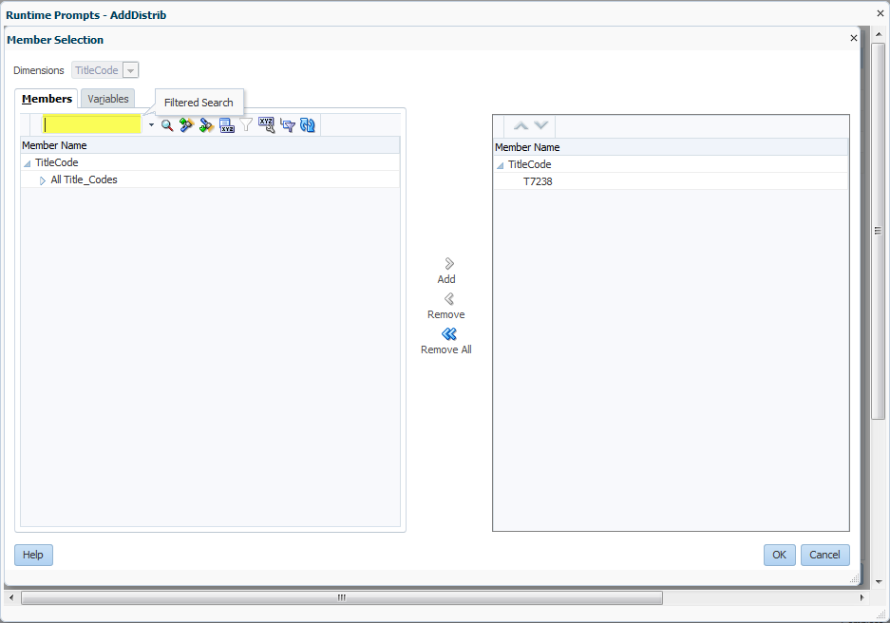
- If the pay component account needs to be adjusted, click in the member selection pull-down icon. There are only 3 pay components to choose from. Click on the appropriate pay component account and click the Add arrow.
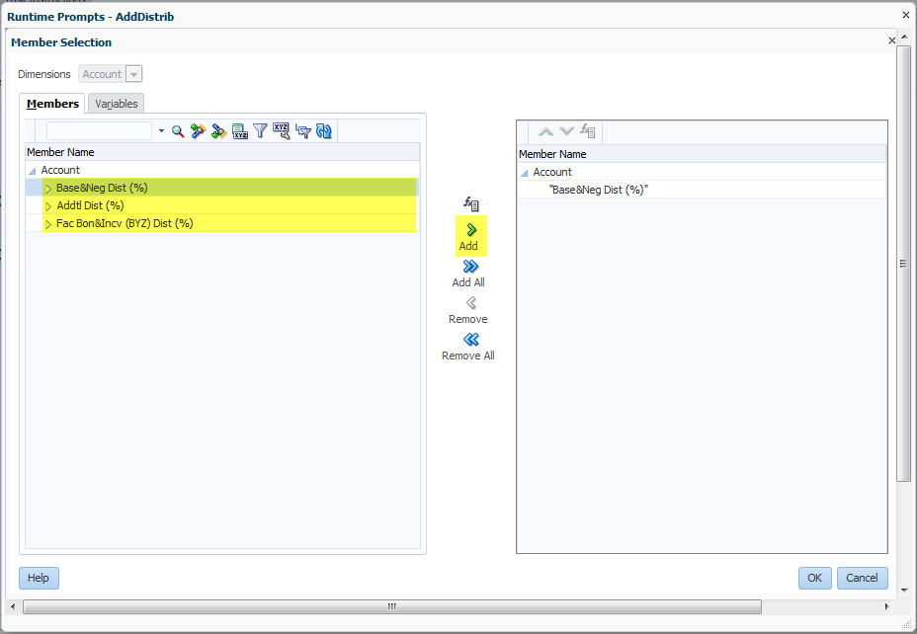
- Click OK button at the bottom right to return the value to the Add_Dist prompt. Note that you may need to scroll down and to the right to see the OK button.
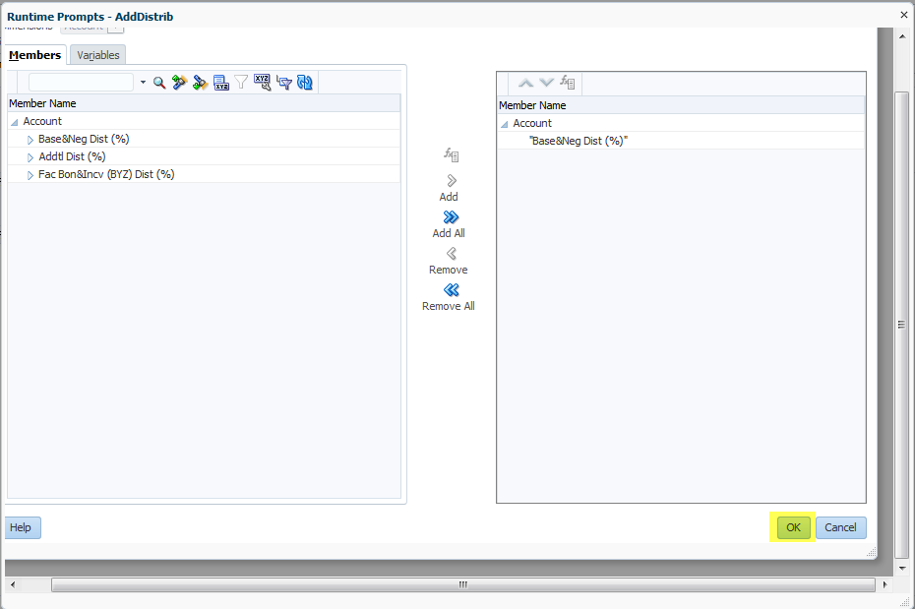
- On the Add_Dist prompt prompt, repeat these steps to adjust the Funding DeptID, Fund and Project.
- When you have finished filling in all fields, click the Launch button. 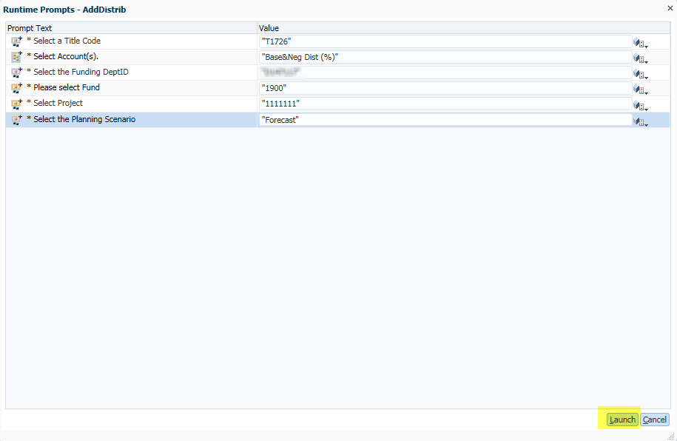
- A message displays, indicating the distribution was successfully added. Click OK to view and add percentages to the new distribution row.
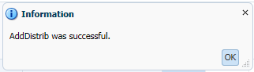
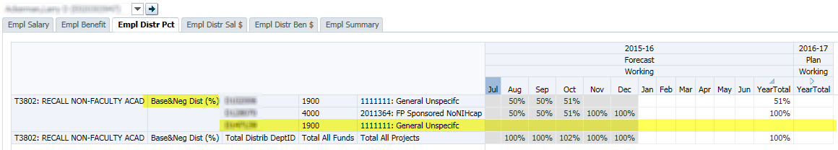
- Enter distribution percentages for this new distribution and save to calculate the distribution dollars for salary and benefits.
To delete a distribution:
- Make sure that there are no percentage values in the DFP distribution row, otherwise, the system will not allow you to delete the row.
- Right-click on the Project field (in the right most column) for the row you want to delete and select Delete_Dist. 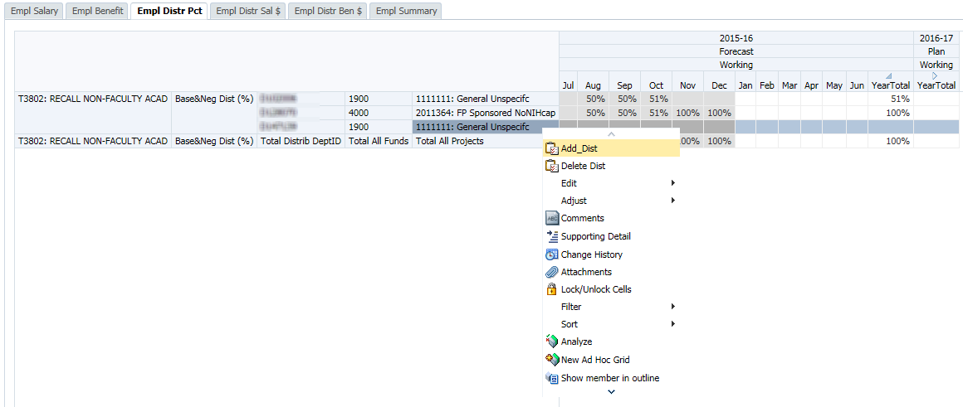
- The selected row will be deleted and a message displays, indicating the distribution was successfully deleted.
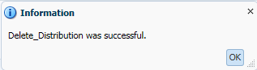

Distribution Percentages
You should know the percentages you are distributing from each of your own DFP combinations, and how this fits into the overall distribution for the employee. You may need to communicate with other departments funding the individual employee. In addition, you can view current percentages using payroll reports in MyReports or the various distribution forms/reports in UPlan.

More than 100%?
You may notice that the total Base&Neg % for an employee may exceed 100%. This will occur if the selected employee has one or more distributions in PPS that are at 0% but are actually paid at 100% of the pay rate (such as NIH over-the-cap pay). This could also occur for actuals if an employee received retroactive pay that exceeded the normal 100% of the salary rate level for the month.
UPlan requires a percentage in order to calculate the dollar amount so you may need to inflate the distribution percentage to account for these types of pay. Other examples include post-doc employees who have stipends that are treated as base pay.

Tab 4 Distributed Salary and Tab 5 Distributed Benefits
Tabs 4 and 5 display the calculated dollar amounts of planned pay distributions by DFP.
- Tab 4 (Empl Distr Sal $) shows the distributed salary amounts for each salary component and DFP combination. 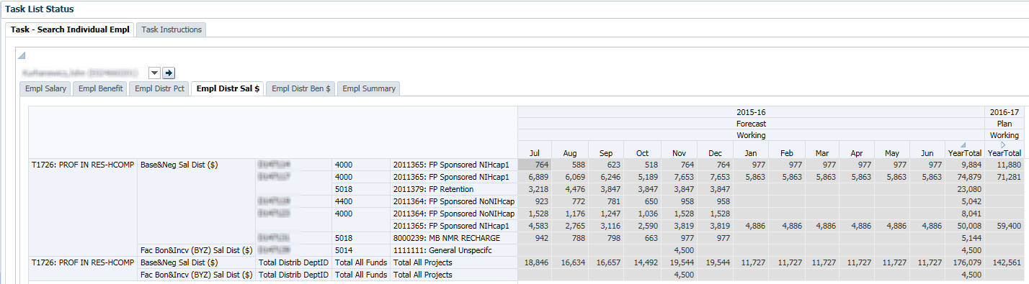

- Tab 5 (Empl Distr Ben $) shows the distributed benefits amounts for each salary component and DFP combination. 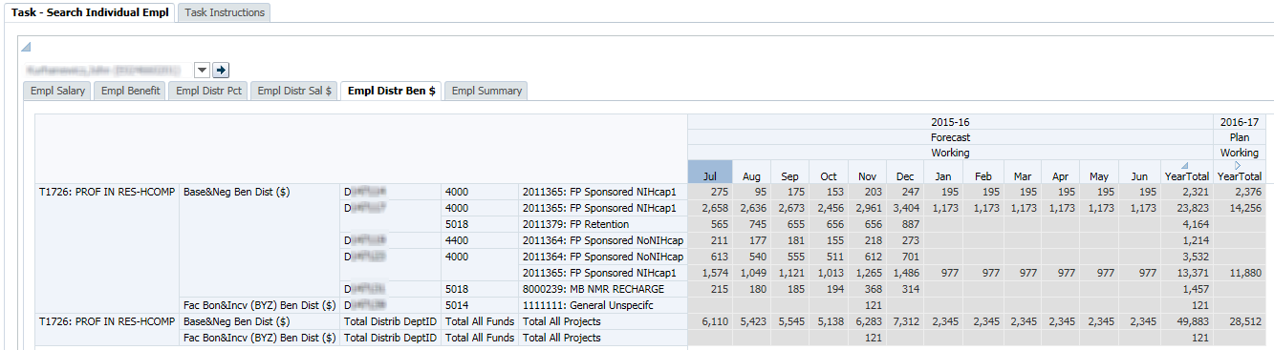

These forms are not writable. Once salary rate levels, benefit rates, and distribution percentages on other tabs are entered for the relevant pay component, the distribution dollar values on these two tabs are updated for the open months upon save. Totals by title code and pay component are displayed at the bottom of the form.
Once a month closes, salary and benefit actual expense will populate from the payroll sub-ledger (Distribution of Payroll Expense or DPE) to these two tabs.

Tab 6 Employee Summary
Tab 6 (Empl Summary) contains summary information about the employee. In addition to Title Code and (home) DeptID, rows include various employee characteristics. If desired, planners can update values for Rank, Step, and FTE. Other values are calculated based on the New Base&Neg salary level from Tab 1 Empl Salary.
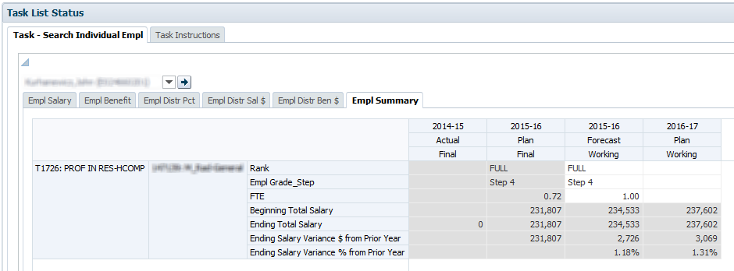

Rows (Accounts) | Description
Rank | Smart List indicating a title code’s rank (only applicable to some faculty and non-faculty academics titles). Choices are: NA, FULL, ASSOC, ASST, INSTR. This is informational only and is not used in calculations.
Empl Grade_Step | Smart List, with a drop down box giving you choices for grades or steps. For employees with no grade or step, select NoGradeStep. This is informational only and is not used in calculations.
FTE | Full Time Equivalent; enter 1.0 for Full time; 0.5 for half time, etc. This is informational only and is not used in calculations.
Beginning Total Salary | New Base&Neg Salary Level at the beginning of the period (July)
Ending Total Salary | New Base&Neg Salary Level at the end of the period (June)
Ending Salary Variance $ | Year-over-year dollar change in Ending Total Salary
Ending Salary Variance % | Year-over-year percentage change in Ending Total Salary

2.2 Employee Landing Page
The Employee Landing Page lists all of the employees in a selected MyOrg. Rows are the DeptID (home), Employee, and Title Code. Columns include the current year forecast and Year 1 plan with additional account detail.
The Landing Page gives you a view of employees and their compensation information to help determine whether adjustments need to be made. You cannot edit data on this screen, as is indicated by the gray cells.
From this Landing Page, you can select an employee or TBH, right-click, and select the Go to Empl Forms or Go to the TBH Forms to navigate to the selected employee or TBH’s individual forms to make edits.
For both the Current Year Forecast and the Year 1 Plan, the following data elements are displayed in columns.
Columns (Accounts) | Description
New Base&Neg Salary | Year-total base and negotiated salary level planned
FTE | Full Time Equivalent value for the Employee/Title Code intersection. The FTE values come from the Empl Summary tab of the Employee Composite form.
Base&Neg Dist (%) | Total percentage of Base and negotiated salary planned for June
[FTE-Base&Neg Dist%] | Difference between the FTE value and the total percentage of Base and negotiated salary planned for June; a non-zero value indicates that either the FTE value or the planned distributions are incorrect and should be adjusted.
*Note: If you get a message that you must set MyOrg before you can access the form, you must set the MyOrg in Preferences>User Variable Options. After entering your selected MyOrg DeptID, click save.
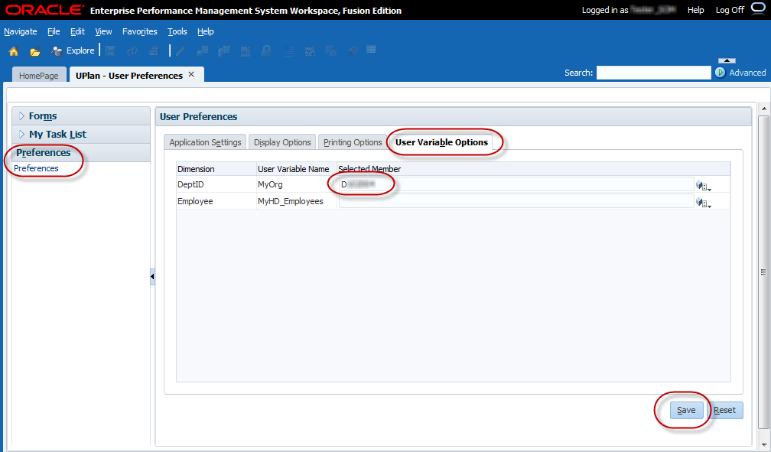

Who Appears on Your Landing Page
Employees who are owned by your planning DeptIDs will appear on the landing page, based on the MyOrg you selected, for each planning DeptID. Employees for whom you provide salary and benefit funding, but do not own, will not appear on the Landing Page unless you choose the MyOrg planning DeptID that owns them.
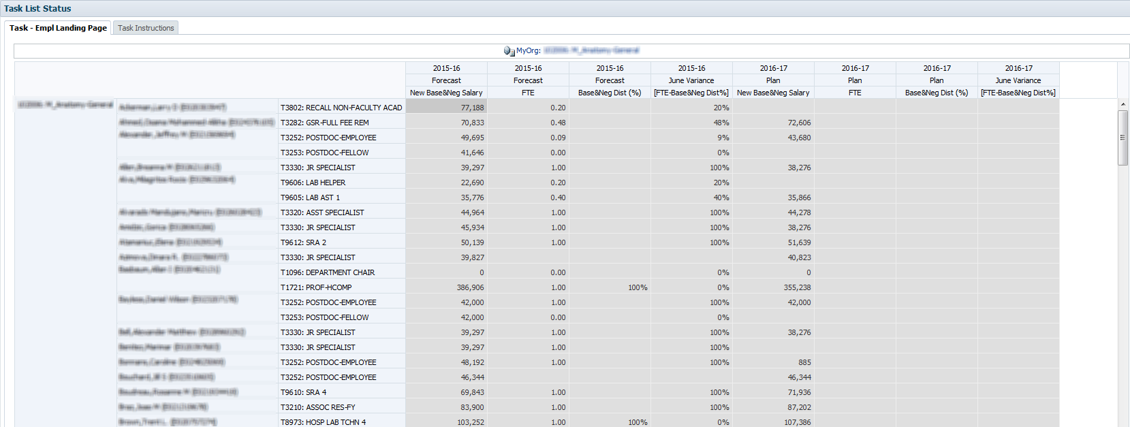

Right-Click Menu Options
From the Employee Landing Page, planners can navigate to the individual employee or TBH form and make adjustments for that employee. The individual employee or TBH forms are named “Search Individual Empl” and “Search Individual TBH”, respectively.
To navigate to the individual employee or TBH form:
- Right-click on the Title Code for the Employee or TBH you want to adjust and select Go to Empl Forms or Go to TBH Forms. 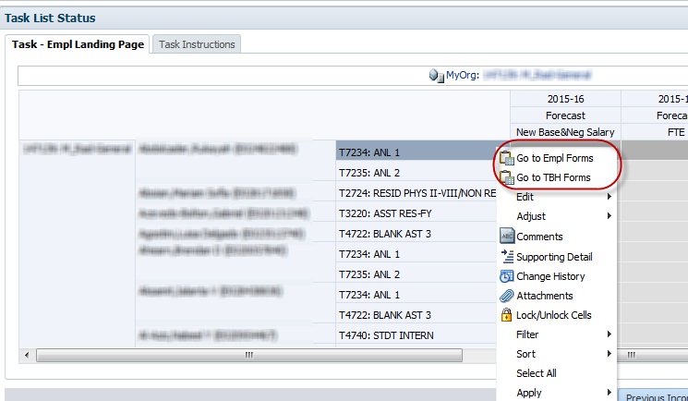
- The Search Individual Empl or Search Individual TBH form will appear. The Page Filter will reflect the selected Employee or TBH. 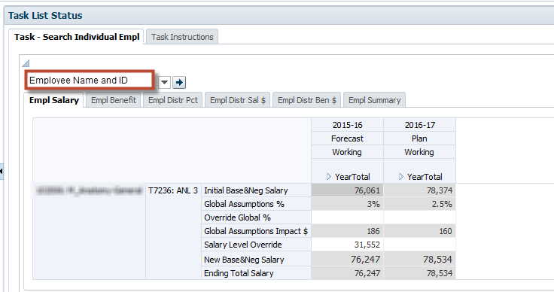 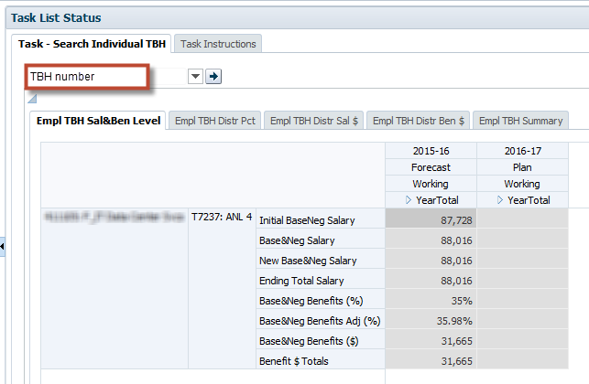
- Select the tab where you want to adjust data and make your changes.
- To return to the landing page, you can click on the Employee Landing link on the breadcrumb at the top of the form. Another option is to click on the Empl Landing Page under My Task List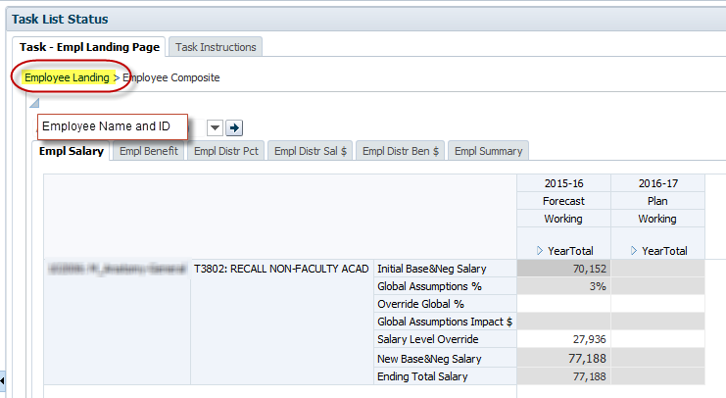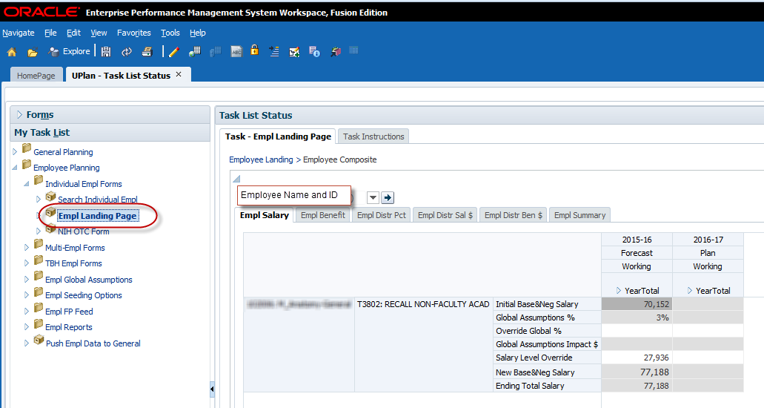

2.3 NIH Over-the-cap (OTC) Form
Employees who are paid from NIH sponsored projects may have a salary amount that is in excess of the NIH salary cap, known as the NIH OTC amount. Note that the policy for NIH salary caps are determined by the National Institutes of Health agency (not UCSF or UPlan) and apply to all of their project awards that fund salary and benefits. More information about the salary caps is available on their website http://grants.nih.gov/grants/policy/salcap_summary.htm.
Planners can opt to use the NIH OTC form to add non-NIH project funding distributions to cover the NIH OTC amount. This optional form is only available for existing employees and not available for TBH employees. For each employee funded from an NIH project, UPlan determines whether there is unfunded salary and benefits due to the NIH salary cap(s) and these are shown on the NIH OTC form. Planners determine and add the non-NIH funding DFP distribution(s) to cover the NIH OTC amount as needed on the form.
The NIH OTC amount is auto-calculated for each applicable salary and benefits distribution for the planning-only and adjustment projects for NIH sponsored projects (e.g. 2011365: FP Sponsored NIHCap1, 2011366: FP Sponsored NIHCap2, ADJ Sponsored NIHCap1, ADJ Sponsored NIHCap2, etc). The salary and benefit distribution dollars are aggregated to these planning-only sponsored projects and calculated against the salary rate level and benefit rate level to determine the NIH OTC amount. Note that the NIH OTC amounts calculate against the total distributions for the FP Sponsored NIHCap and the corresponding ADJ Sponsored NIHCap projects (e.g. total for 2011365: FP Sponsored NIHCap1 and ADJ Sponsored NIHCap1).
The calculations follow the methodology directed by NIH and consist of five general steps:
- Calculate the monthly total salary amount from the annual salary
- Calculate the allocated monthly salary amount supported by an NIH grant
- Calculate the capped monthly NIH salary amount
- Calculate the unfunded salary amount
Calculate the associated unfunded benefits amount

NIH OTC Form
The NIH over-the-cap (OTC) salary and benefit amount for an employee funded by an NIH award(s) is displayed on the top section of the NIH OTC form. The bottom section allows the planner to add non-NIH project distributions to fund the OTC amount.
- You may add multiple distribution rows by right-clicking on the project and selecting Add NIH Distribution. Likewise, distributions can be deleted by selecting Remove NIH Distribution
- Distributions will be entered by month as percentages for the DFP(s) and should total 100% to fully cover the NIH OTC $ amount.
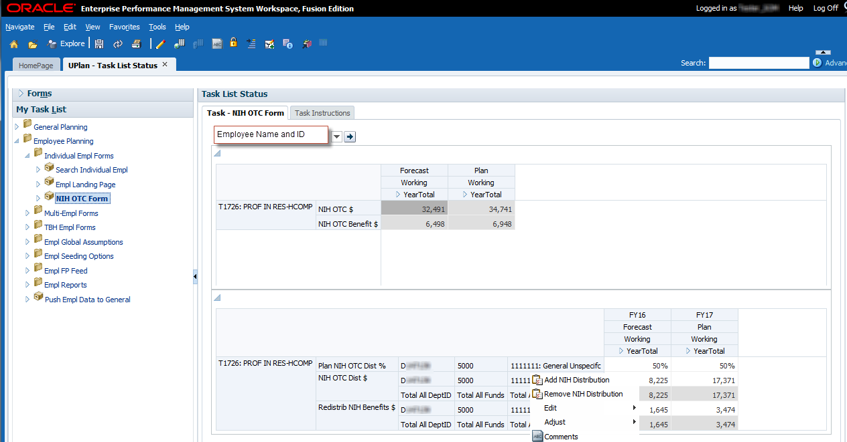

Distributions for employees with NIH OTC $ amounts should be carefully reviewed as possible since duplications may exist where the NIH over-cap-amount is already accounted for. Below are some examples of cases where you may not want to use the NIH OTC form.
- Distributions to cover the NIH OTC $ are planned for in Faculty Portfolio under the retention, recruitment, or other faculty/PI project use and the distribution percentages may copy over if you had copied over the FP Feed employee data.
- You or another planner may have already added non-NIH DFP distributions to cover the NIH OTC amount in the Empl Distr Pct tab of the individual employee form or the Multi-Empl Distr Pct form.
- UPlan cannot identify whether these duplicate distributions are related to covering the NIH OTC amount. Some tips to identify whether these duplications exists include:
  - The NIH OTC amount is a pay type where in PPS, the pay distribution % are at 0% but are actually paid at 100% of the salary rate so if these are included, the total distribution percentages for the Base and Negotiated pay component shown on the Empl Distr Pct tab of the individual employee form will likely be over 100%.
  - Communicate with your Research Support Analyst (RSA) who plans within Faculty Portfolio or your payroll processor who enters data within PPS.

3.0 Multi-Employee Forms
Two multi-employee forms are provided at this time, one for salary and benefit rate level adjustments and one for pay distribution adjustments. These forms meant to enable planners to add planning information in a time-efficient manner and may not allow planning for the additional or faculty bonus/incentive pay components. Both forms also allow you to navigate to the individual employee or TBH forms via the right-click menu to make additional edits to specific employees.

3.1 Multi-employee Salary and Benefit Level Form
The Multi-employee Salary and Benefit Level form allows planners to edit base and negotiated compensation for employees owned by the selected MyOrg DeptID. For efficiency in planning, this form does not include the Additional and Faculty Bonus/Incentive pay components; if you need to plan for these pay components in your Forecast or Year 1 Plan for an employee, please do so in the individual employee form. Planners can view existing data related to the base and negotiated salary and benefit levels and enter an updated salary value and a benefit adjustment percentage for multiple employees on the same form. There is no right-click menu ability to add or delete accounts.
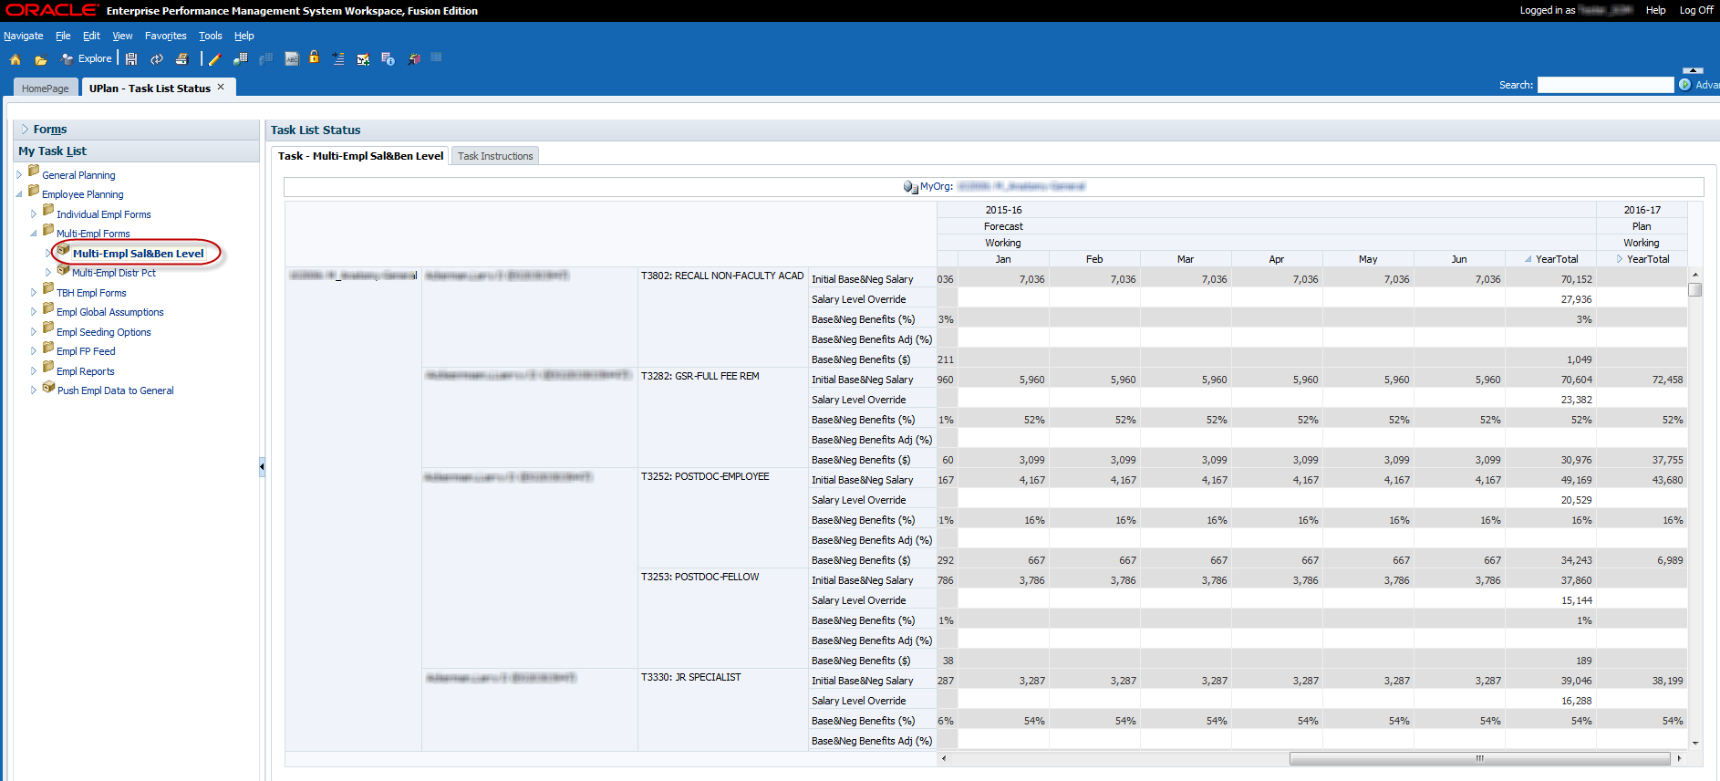
- Page Filter: MyOrg
- Rows: (home) DeptID, Employee, Title Code, and Account (five base and negotiated salary and benefit accounts)
- Columns: Year, Scenario, Version, and Period (months)
For each Employee and Title Code, the following five rows will appear on the form:
Account | Use
Initial Base&Neg Salary | Read-only
Salary Level Override | Enter the corrected salary value to override the Initial Base&Neg Salary
Base&Neg Benefits (%) | Read-only
Base&Neg Benefits Adj (%) | Enter the benefits adjustment percentage for each month to override the Base&Neg Benefits (%)
Base&Neg Benefits ($) | Read-only

3.2 Multi-employee Pay Distribution Form
The Multi-employee Pay Distribution form allows planners to add or delete distributions for employees funded by the selected MyOrg DeptID. The layout and functionality of the form is similar to tab 4 of the individual employee form where planners can view existing distributions, make adjustments to those distributions and add or delete distributions. This form includes distributions for all pay components.
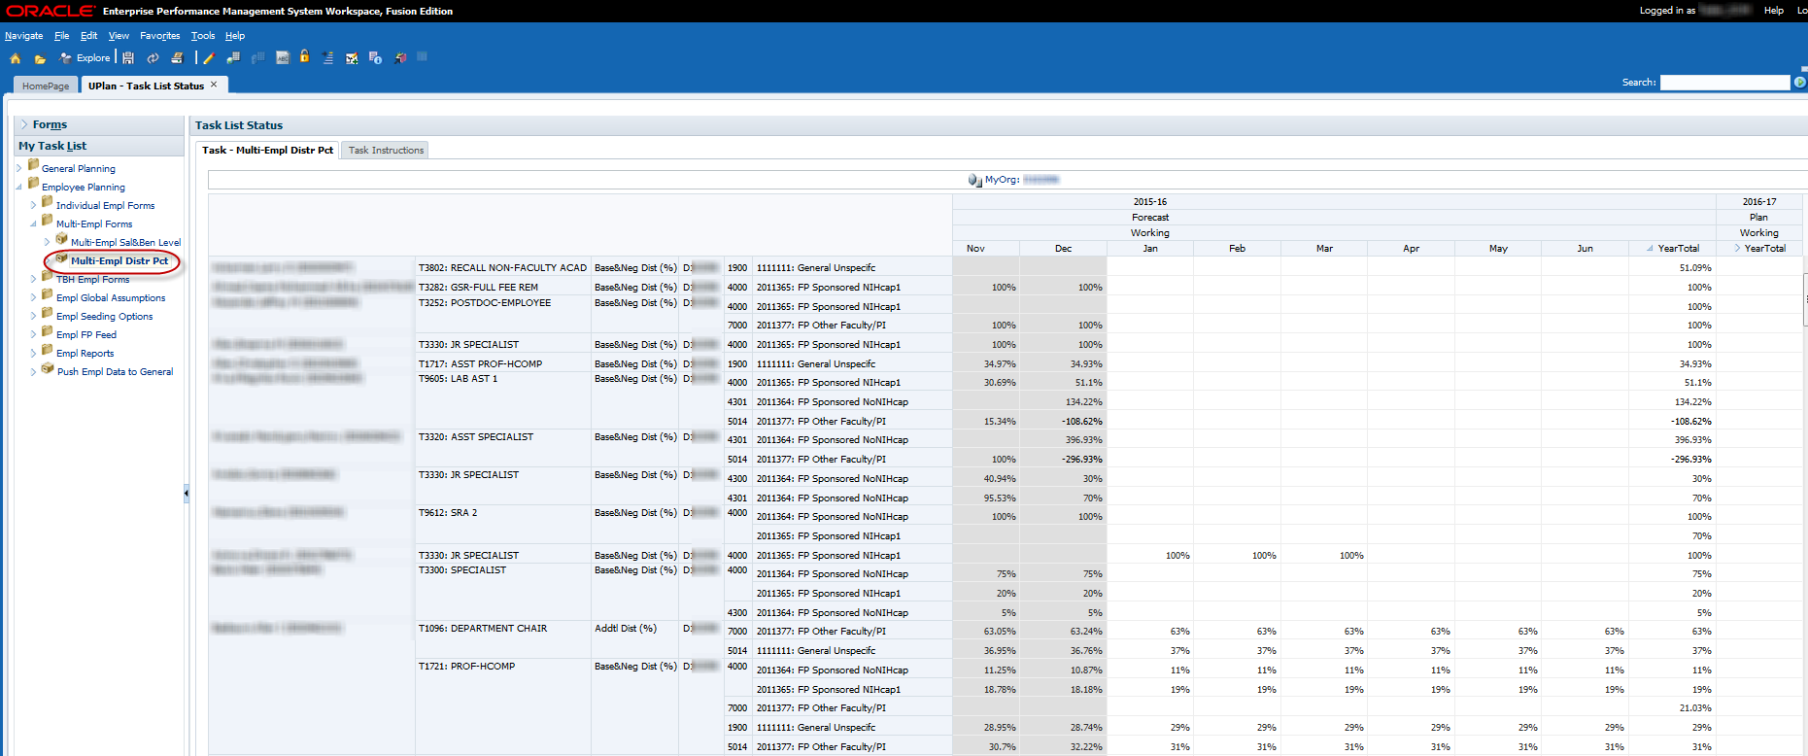
- Page Filter: MyOrg
- Rows: Funding DeptID, Employee, Title Code, Pay Component, DeptID, Fund, and Project
- Columns: Year, Scenario, Version, and Period (months)

You can add and delete distributions by right-clicking on the Project and selecting Add Dist or Delete Dist.
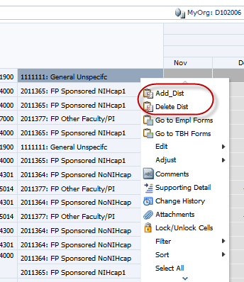
Hint: You can make changes for multiple employees and submit (save) the data to UPlan when you are finished. However, if you are going to add or delete distributions, you should submit/save any changes you have made up to that point.

4.0 To-Be-Hired Employee Forms
This section covers how to plan for To-be-hired (TBH) employees, including the following topics:
- Use the TBH forms for group provisions
- Use of the TBH Landing Page Form
- Adjust TBH employees’ salaries
- Add and adjust distributions for to be hired employees
- Understand how data is seeded for TBH provisions

What is a TBH Provision?
A TBH provision is placeholder for an individual or group of employees to be hired. Throughout this lesson, these are referred to as either “TBH provisions”, “TBH employees”, or simply “TBH”. TBH provisions could also be used for salary savings and reductions or additional salary funding you expect to distribute to specific DFP’s but don’t know exactly which specific employee would be impacted. In fact, you can use a TBH whenever you want to capture a change in any salary/benefit expenditure in the forecast or Year 1 plan.
As with existing employees, you can plan salary and benefits for the three pay components for TBH provisions you own (e.g. the TBH’s belong to your home department). You along with planners in other departments who fund the TBH provision can plan the funding DFP distributions.
- The TBH Employees Landing Page is where you can create the new TBH provision to begin planning.
- You can provision TBH employees one by one, based on specific requisitions you have or expect to have over the coming forecast or Year 1 plan horizon.
- In addition, you can leverage the TBH Employees forms to plan on a group level for some or all of your salary and benefit expenses.
- The Search Individual TBH Form is where you modify detail data about your TBHs
- TBH’s can also be modified on the two Multi-Employee forms

Using TBH for Group Provisioning
Once the new TBH is created, you can leverage the Search Individual TBH form to plan on a group level for some or all of your salary and benefit expenses. Here are some examples:
- You can include a line item for five new professors.
- You can plan for 20 new full time staff employees.
- You can add a “dummy” TBH that covers the expected salary and/or benefit increases for the entire DeptID.
- You can include negative entries to show savings in employee expenses.
- You can add to be hired employees whom you will only fund but do not own.

4.1 TBH Landing Page Form
The TBH Landing Page is where you add new TBH provisions and is read-only. Once you begin to add TBH entries, the Landing Page serves as a roster of TBH’s for your DeptID and you can navigate to the Search Individual TBH forms to edit the salary rate level, benefit rate level, and the funding DFP distributions by pay component.
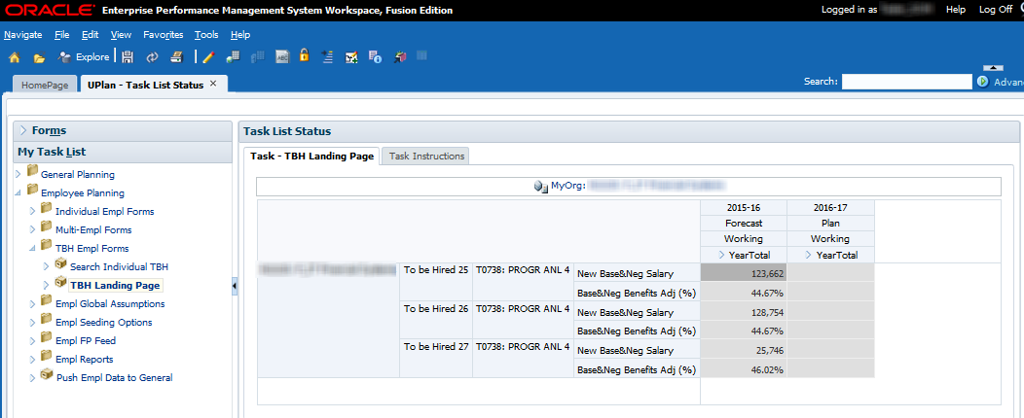
- Page Filter: MyOrg
- Rows: (home) DeptID, Employee (To Be Hired #), Title Code, and Account)
- Columns: Year, Scenario, Version, and Period (months)

TBH Numbering
Each time you add a TBH, UPlan generates a unique To Be Hired number. Since TBH employees may be funded by multiple departments, you may share the same TBH employee to add distributions. If you delete a TBH, that number will be available for automatic re-assignment by UPlan when you or another planner adds a new TBH. TBH Employee numbers will be very simple, such as To be Hired 1, To be Hired 2, etc.
Hint: If you do not need an existing TBH but want to keep the same TBH number for future use, delete the salary rate level, benefit rate levels, and distribution details of the TBH but do not delete the TBH itself. The TBH number will then still be “owned” by your DeptID.
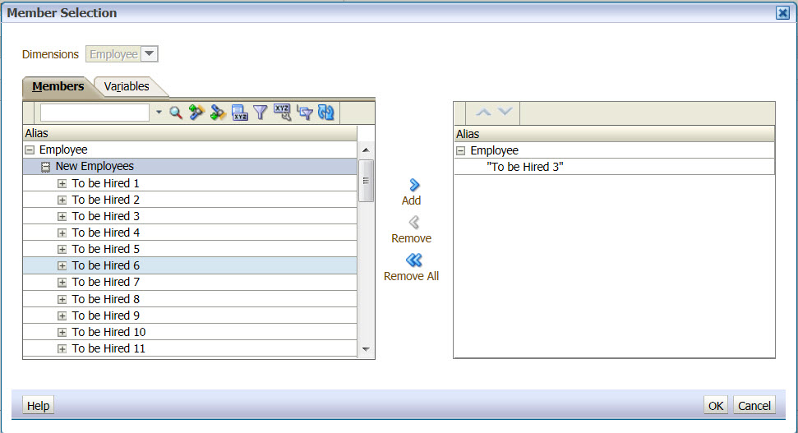

Base Salary Calculation for TBH Employees
For To be hired employees, global assumptions do not apply. If you plan to fill the TBH provision to include merit and other salary increases, simply enter the full salary rate level amount in the Base&Neg Salary.

Negative Provisions
Planners will be able to create (or delete) provisions for planned new hire and negative provisions for salary savings due to separations or budget reductions.
For example, if you’re expecting $10,000 in salary savings, you can create a TBH with -10000 as base salary. Remember that the amount is pro-rated based on hire date.

Salary Distributions
Just as with existing employees, you will need to enter funding DFP distribution(s) whenever you fund all or part of that TBH employee’s salary. This is true whether the TBH is in your salary level planning home DeptID or not.
- For TBH employees that you own and fund, you will adjust distributions.
- You will also adjust distributions on TBH employees you fund who are not in your salary level planning DeptID.
- Remember you will need to coordinate this with the salary planning level DeptID to obtain the correct TBH Employee number in order to add a pay distribution for this TBH provision. Note that you will need to use the Search Individual TBH forms to access the distribution form.

Right-Click Menu Options
From the TBH Landing Page, the planners can select one of three options:
- Add TBH
- Delete TBH
- Go to TBH Forms
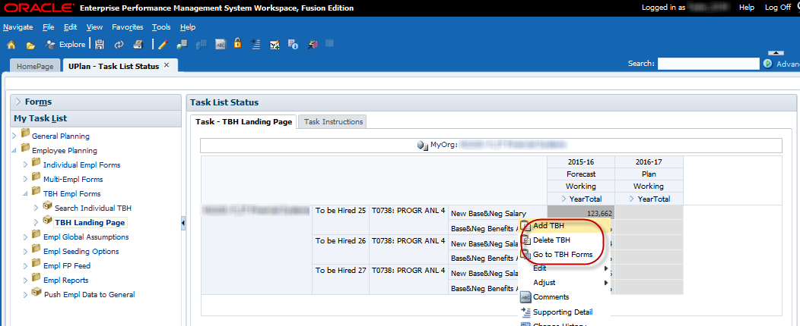
Note: Before any TBH rows exist, you will access the menu by right clicking in the blank row placeholder, to the left of the first column. Once there are TBH rows, you will access the right-click menu by clicking in the right-most row heading, which holds Accounts. 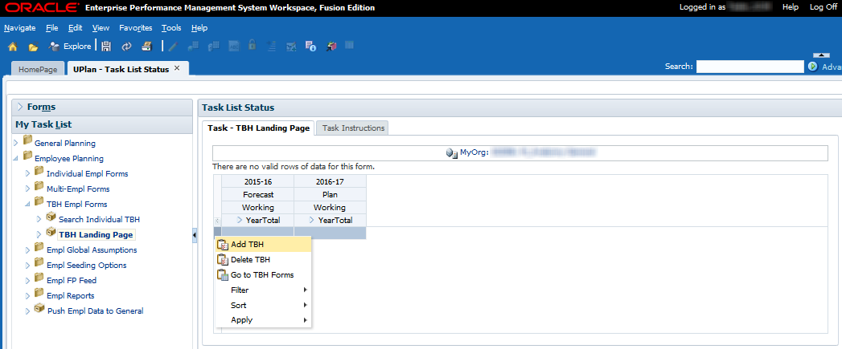
To add a TBH:
- Right-click on the right-most row header and select Add TBH
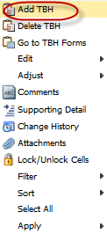

- A prompt will appear. 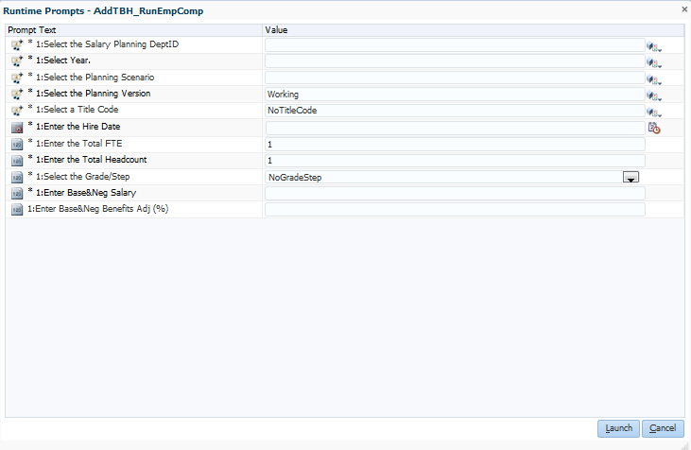

- Use the Member Selection icons or enter data into the Value column to build the TBH you want.
The following table describes the fields for which you will be prompted. Certain fields will prepopulate based on where your cursor is when you selected the Add TBH.
Field | Details
Salary Level Planning DeptID | - Enter the Home DeptID, preceded by the letter “D”; must be a planning-level DeptID
Year | - Enter the specific fiscal year for the Forecast or Year 1 (e.g. FY16 or 2015-16)
Planning Scenario | - Enter “Forecast” or “Plan”
Planning Version | - Enter Working
Title Code | - Select a specific Title Code; the code must be preceded by the letter “T”  - Select NoTitleCode to plan for many employees with different job functions or if you don’t yet know what the title code will be  - Note that “NoTitleCode” flows to General Planning “staff” staff and benefit accounts upon integration
Hire Date | - Enter a date in the format M/D/YY or use the calendar look-up feature  - The data entered will prepopulate the months for the salary rate level, benefit rate level, and DFP distributions. For example, if the planning scenario is Forecast and 3/1/16 entered as the hire date, March-June  of the Forecast will pre-populate.
Total FTE (Full Time Equivalent) | - Enter 1 for a specific individual full time requisition  - More than one headcount can equate to one full time equivalent employee (e.g. you can have 1 FTE but 2 headcount if TBH represents 2 part-time provisions)  - Type a decimal for one part time hire (such as .50 for one half time)  - Type a whole number greater than 1 to indicate group provisions; can be multiple full time or part time individuals, and it can be for similar title codes or generic title codes
Total Headcount | - Enter the number of individuals this FTE entry represents
Grade or Step | - Defaults NoGradeStep; selections can be made from the dropdown list
Base&Neg Salary | - Enter a whole number (with no commas)  - Enter the annualized salary; the monthly amount is pro-rated based on hire date entered  - If TBH is a group provision, the value should be combined total base and negotiated salary of the FTE and headcount (e.g. 5 FTE/headcount @ $50,000 = $250,000)
Base&Neg Benefits Adj % | - Enter the percentage benefits rate to be applied to the base and negotiated salary  - Simply enter the value without formatting. Do not use the % sign or the decimal. For example, if you want to enter a 15% benefits rate, simply enter 15, not 15% or 0.15.
- Once you have adjusted the various field values, hit Launch.
A message displays, indicating the TBH was successfully added. Your new TBH will appear on the TBH Landing Page.
- Click OK.
The TBH Employees Landing Page appears, with a row for the TBH provision you added. The TBH employee will appear within the DeptID you entered. Remember, you will still need to add funding distributions for this TBH by navigating to the Search Individual TBH form via the Go to TBH Forms right-click menu and entering data in the Empl TBH Distr Pct tab.
To delete a TBH:
- Right-click on any account for the TBH you want to delete and select Delete TBH.
A prompt will warn you that you are about to delete a TBH.
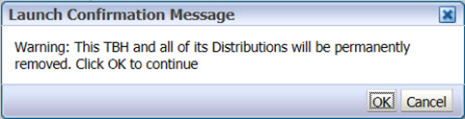
- To confirm you want to delete the TBH, click OK.
A message appears, indicating that you successfully removed the TBH.
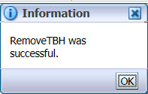
- Select OK.
To adjust data for a TBH:
- Right-click on any account value in the row for the TBH you want to adjust and select Go to TBH Forms. This will take you to the Search Individual TBH form to make adjustments.

4.2 Search Individual TBH Form
The Search Individual TBH form is where you make adjustments to an individual TBH. Similar to the Search Individual Employee form, this form is a composite with multiple tabs, but unlike the Search Individual Employee form, the Search Individual TBH form combines the tabs for salary level and benefit rate adjustments on a single tab. Add or delete salary and benefit pay component accounts or pay distribution DFPs as needed using the right-click menus on the various tabs.
To adjust data for a TBH provision, use the same functionality as described in Section 2.0 related to the Individual Employee forms. As with individual employees, you can perform the following:
- Adjust salary rate level and benefit rate by pay component on Tab 1 – Empl TBH Sal&Ben Level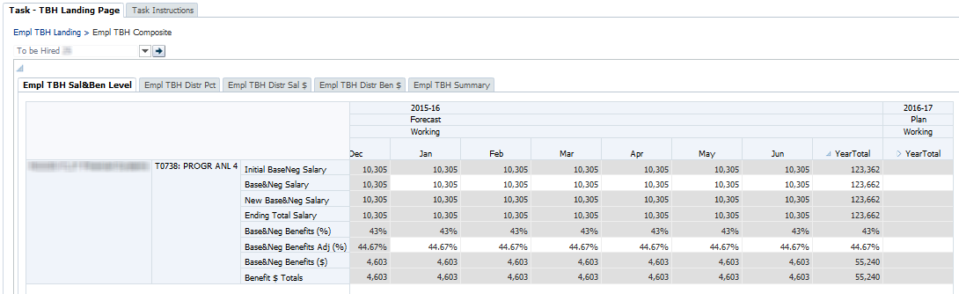

- Adjust funding DFP distribution percentages and Add or delete a DFP distribution on Tab 2 – Empl TBH Dist Pct 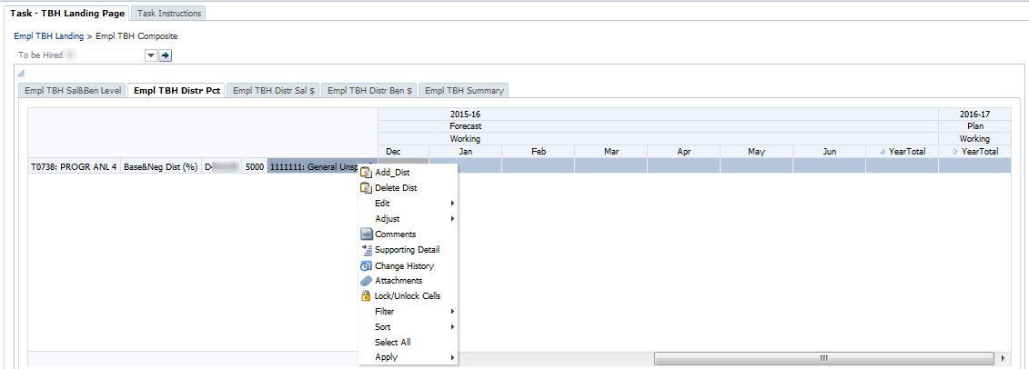

- View calculated salary and benefit dollar distributions on Tab 3 – Empl TBH Distr Sal $ and Tab 4 – Empl TBH Distr Ben $ 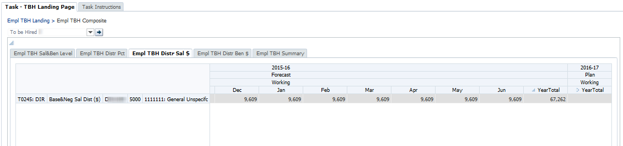
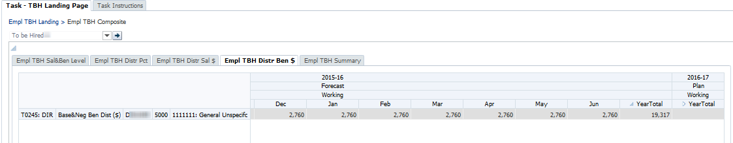
- Adjust TBH characteristics on Tab 5 – Empl TBH Summary 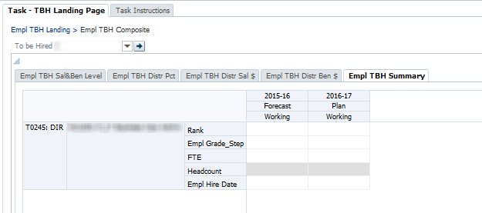

5.0 Employee Planning Global Assumptions and Seeding
This section provides an overview of global assumptions and seeding in the Employee Planning module. In Employee Planning, the UPlan Administrator in Budget and Resource Management office (BRM) initially sets global assumptions for salary increases (these assumptions are based on information from Human Resources). Planners with Level 1 or 2 Coordinator access can then adjust these global assumptions for their departments. BRM does not establish any global assumptions for benefits though Level 1 or 2 Coordinators can make adjustments for their departments. On the other hand, the UPlan system allows seeding to be done by any planner for their DeptID’s though you should check with your Control Point Coordinator or Dean’s Office to insure that they do not have internal processes in place where they handle the seeding.
- The application of global assumptions for salary increases is based on title unit codes, most of which are bargaining units.
- Control points (Level 1) and Level 2 departments can adjust global assumption rates for salary increases.
- Global assumptions for salary increases can only be applied to the base and negotiated salary for the Forecast, Year 1 plan, and Year 2 plan.
- Global assumptions are reflected against salary level upon save in the Salary Global Assumptions form.
- BRM usually sets the salary global assumption in February of every year. If Control Points and Level 2 departments plan to change the BRM assumptions, it is advisable for them to set timelines for adjusting global assumption rates as it will impact the Base and Negotiated salary level for all employees in their departments.
- Planners can override global assumptions for base and negotiated salary at the individual employee level.
As noted above, only planners with Coordinator access have the ability to adjust the Global Assumptions form, and only at the Level 1 and Level 2 levels of the DeptID tree. Planners can view the global assumptions on the Salary Global Assumptions form or on Tab 1 Empl Salary of the Search Individual Employee form. To make adjustment for an individual, they can use the Override Global % account on Tab 1 Empl Salary.
Role | Actions
UPlan Administrator | Sets initial global assumptions for Forecast, Year 1, and Year 2 which pushes down to Level 1 and Level 2 Coordinators.
Level 1 Coordinator | Adjust global assumptions. Upon save, UPlan pushes the adjusted global assumptions to all DeptIDs within the control point.
Level 2 Coordinator | Adjust global assumptions. Upon save, UPlan pushes the adjusted global assumptions to all DeptIDs within the department.
Planner | Adjusts Forecast and Year 1 Plan. Global assumptions can be overridden by making adjustments for individual employees.
To review global assumptions for Employee Planning:
- From My Task List, select Employee Planning > Empl Global Assumptions > Salary Global Assumptions.
- Check the DeptID in the Page Filter.
- To change the DeptID, click the drop down box in the Page Filter and type the id or number for your DeptID; then click the Go icon.
- Review the effective month percentages entered by BRM or your coordinator(s) for Forecast, Year 1 Plan, and Year 2 Plan.
- 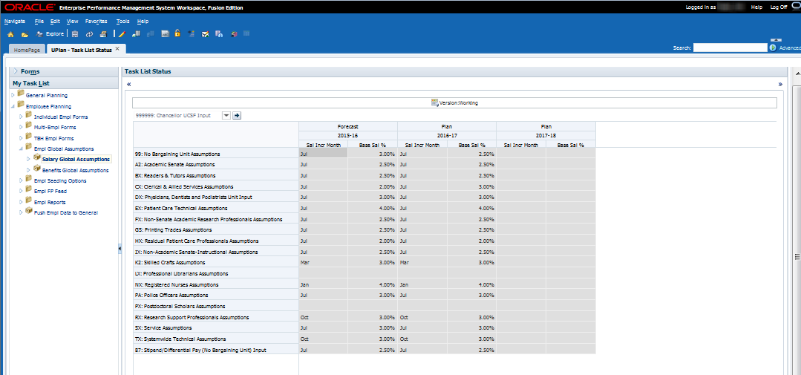

Salary Global Assumptions and To-be-Hired Provisions
As noted in Section 4.2 Search Individual TBH Form, salary global assumptions do not apply to TBH provisions.

Benefit Global Assumptions
Level 1 and 2 Coordinators have the ability to apply benefit global assumptions for their departments. These assumptions must be entered to all applicable months in the forecast, Year 1 plan, and Year 2 plan. For the forecast and Year 1 plan, only the Base&Neg benefit assumptions can be added. For Year 2 plan, assumptions can also be added for the other two pay components, Additional and Faculty Bonus/Incentive. Unlike the salary global assumptions which are multiplied against the salary rate level, the benefit global assumption rates are added to individual employee benefit rates. For example, if the benefit global assumption is 5% and an individual employee’s benefit rate is 30%, then the new rate for this employee is 30%.
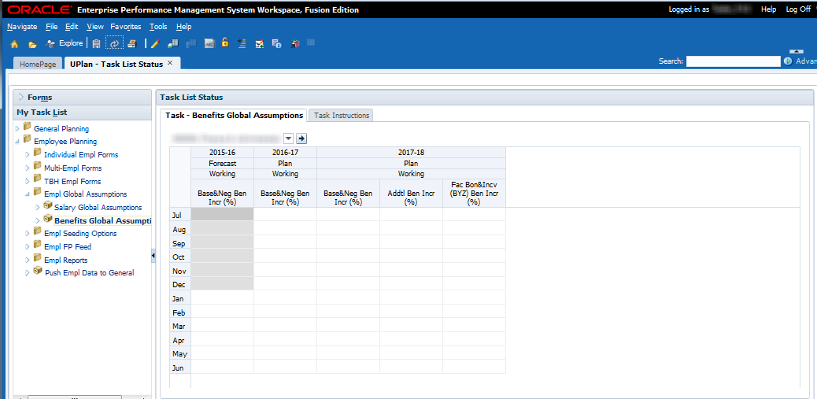

5.1 Seeding in Employee Planning
Employee Planning includes a series of seeding rule options available to planners. These rules are access via the Task List under Empl Seeding Options. Separate seeding rules apply to salary levels, benefits rates, and pay distributions and are applied to the MyOrg DeptID chosen.
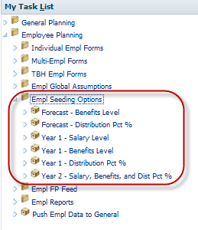
All Employee Planning seeding will include any global assumptions entered by Coordinators. Global assumptions will automatically be applied to planned salary levels from Forecast when the planner runs the Year 1 – Salary Level and Year 2 – Salary, Benefits, and Dist Pct seeding rules.
Planners have the ability to override the benefits rate level and the distribution percentage in the open months of the forecast based on any other month in the Forecast via the seeding rules Forecast – Benefits Level and Forecast – Distribution Pct %. Most of the forecast is pre-populated with the prior year Plan Final data and planners may wish to adjust their forecast across all the employees in their department. These two rules allow them to do so and save time. Note that the seeding the salary rate level in the forecast is not necessary or available since the levels are trued up with PPS data at every month close and therefore, will always reflect the employee’s most current salary rate.
Planners must seed their salary rate level, benefit rate level, and funding DFP distribution percentages. These are based on information from the forecast. After seeding Year 1 Plan, planners will be able to adjust salary levels, benefit levels, and DFP distributions for individual employees for Year 1 via the Search Individual Empl form or the Multi-Empl forms.
Although planners cannot plan or view details for Year 2 plan, they have the ability to seed Year 2 based on information from the Year 1 plan. The seeded information calculates behind the scenes and flow to Year 2 in General Planning. The amounts can then be adjusted at the aggregated salary and benefits accounts in General Planning if needed.

Seeding Rules for Salary Levels
The Year 1 – Salary Level rule allows the planner to seed initial (July) base and negotiated salary levels for the Year 1 Working Plan from any month of any year/ version/scenario. Planner selects the Source Year, Version and Scenario, the Source Month, and the Target Year. In most cases, Planner should select June of the current year as the Source Month to be applied to July of Year 1.
Rule Name | Plan – Salary Level
From Year/Version/Scenario | Any/Any/Any
From Months | Any
To Year/Version/Scenario | Year 1/Working/Plan
To Months | July

Seeding Rules for Benefit Rates
UPlan contains two rules for seeding benefits rates. The first applies to the current year Forecast while the second applies to the Year 1 Plan.
            - The first rule seeds the current year (Year 0) Working Forecast for the remaining non-actualized months of the current year. Planner selects the source month choosing any month from the existing Year 0 Working Forecast (whether the month is actualized or not).
Rule Name | Forecast – Benefits Level
From Year/Version/Scenario | Year 0/ Working/Forecast
From Months | Any
To Year/Version/Scenario | Year 0/ Working/Forecast
To Months | All non-actualized
            - The second rule seeds the Year 1 Working Plan initial benefits rates for all months from any selected month of any year/version/scenario. Planner selects the Source Year, Version and Scenario, the Source Month. Note that global assumptions also apply. Separate global assumptions should apply to July through November and December through June.
Rule Name | Plan – Benefits Level
From Year/Version/Scenario | Any/Any/Any
From Months | Any
To Year/Version/Scenario | Year 1 /Working/Plan
To Months | All

Seeding Rules for Pay Distributions
Two rules for seeding pay distributions allow planners to choose from several options.
- The first rules seeds the current year (Year 0) Working Forecast for the remaining non-actualized months of current year. Planner selects the source month, choosing any month from the existing Year 0 Working Forecast (whether the month is actualized or not).
Rule Name | Forecast – Distribution Pct %
From Year/Version/Scenario | Year 0/ Working/Forecast
From Months | Any
To Year/Version/Scenario | Year 0/ Working/Forecast
To Months | All non-actualized
- The second rule seeds the Year 1 Working Plan for all months, based on a single month chosen by the planner. Planner selects the Source Year, Version and Scenario, the Source Month.
Rule Name | Plan – Distribution Pct %
From Year/Version/Scenario | Any/Any/Any
From Months | Any
To Year/Version/Scenario | Year 1 / Working/Plan
To Months | All

Below are the steps for running these seeding rules:
Seeding the Forecast – Benefits Level
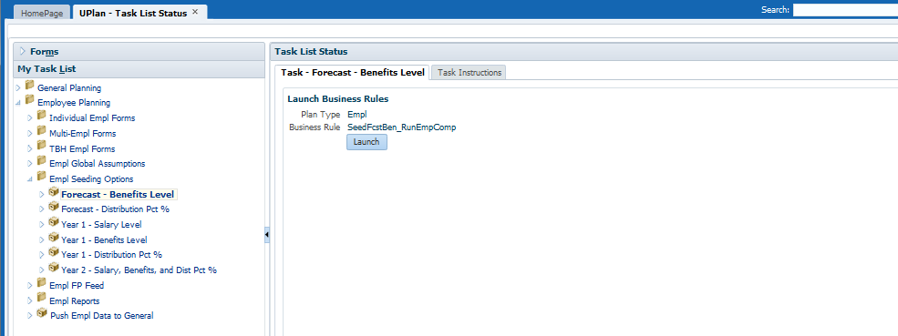

- Click on Launch which will bring up a prompt for you to choose your DeptID that you want to seed for, the source month from the forecast, and the target months that you want to seed to. Click on Launch to run the seeding rule.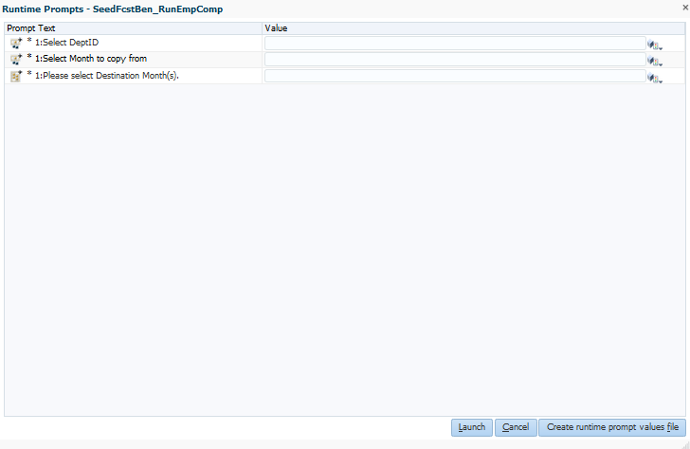
Seeding the Forecast - Distribution Pct % 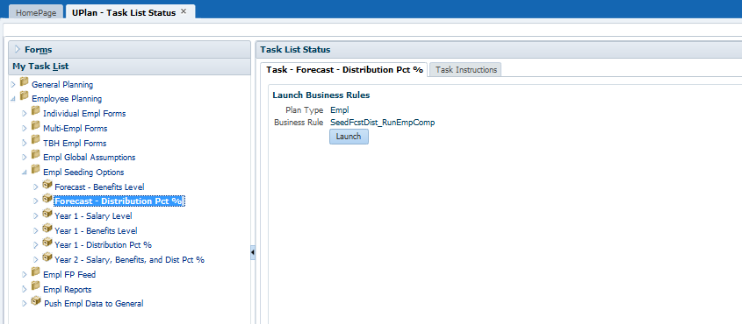
- Click on Launch which will bring up a prompt for you to choose your DeptID that you want to seed for, the source month from the forecast, and the target months that you want to seed to. Click on Launch to run the seeding rule. 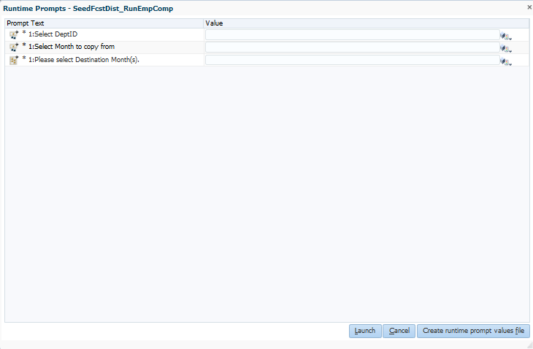
Year 1 – Salary Level 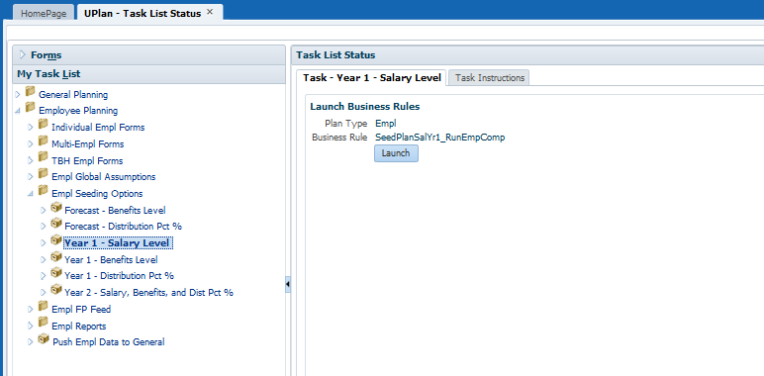
- Click on Launch which will bring up a prompt for you to choose your DeptID that you want to seed for and the source month from the forecast. Click on Launch to run the seeding rule. These will apply to all months in the Year 1 plan. 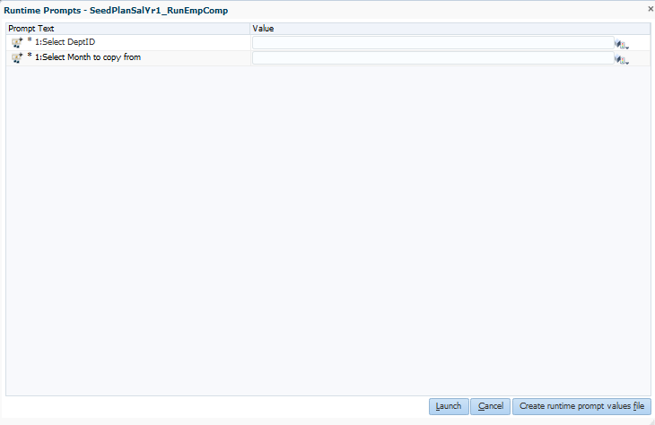
- Year 1 - Benefits Level 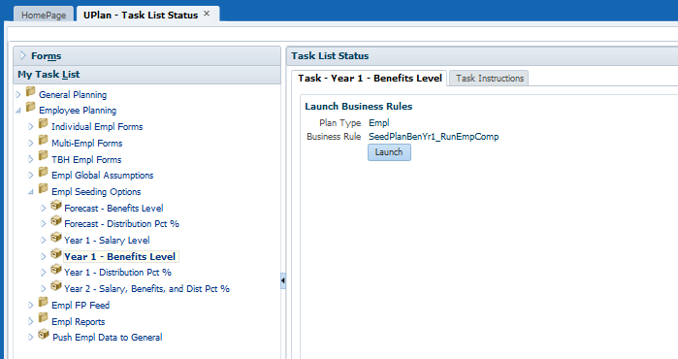
- Click on Launch which will bring up a prompt for you to choose your DeptID that you want to seed for, the source month from the forecast, and the target months that you want to seed to. Click on Launch to run the seeding rule. 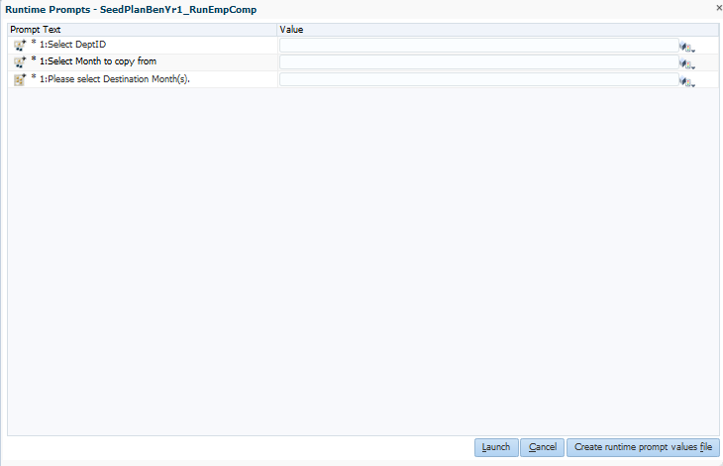

Year 1 - Distribution Pct % 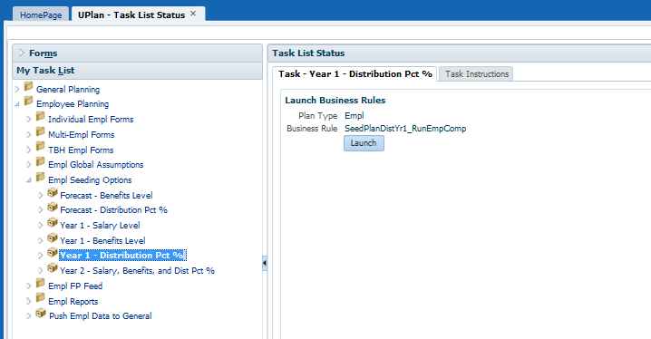

- Click on Launch which will bring up a prompt for you to choose your DeptID that you want to seed for, the source month from the forecast, and the target months that you want to seed to. Click on Launch to run the seeding rule. 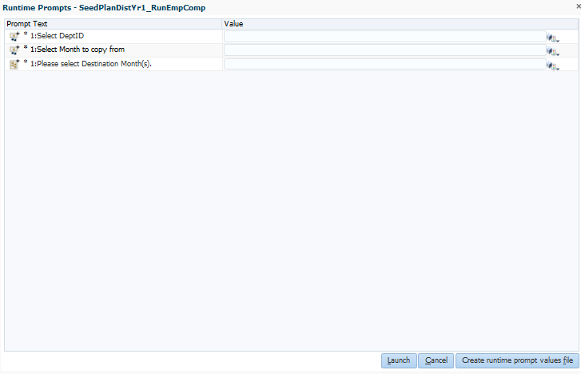
Year 2 - Salary, Benefits, and Dist Pct % 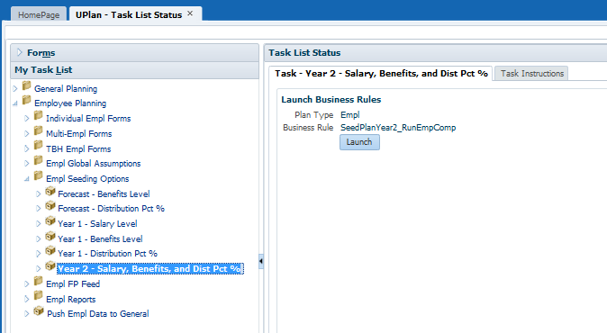
- Click on Launch which will bring up a prompt for you to choose your DeptID that you want to seed for and the source month from the forecast. Click on Launch to run the seeding rule. These will apply to all months in the Year 2 plan behind the scenes and flow to Year 2 in General Planning.
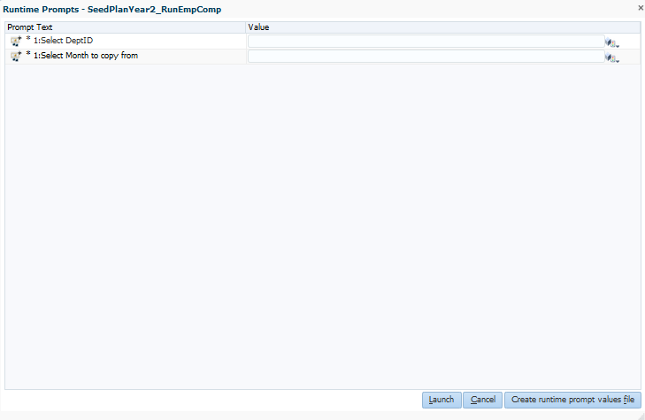

6.0 Faculty Portfolio and Employee Planning
UPlan has an optional feature for planners who use FP and wish to copy over FP payroll distribution percentage data to help avoid duplicative work. Planners that do not use FP can plan directly within UPlan using the planning-only FP projects.
Faculty Portfolio (FP) forecast and Year 1 data is refreshed nightly and available for planners to copy to their UPlan forecast and Year 1 plan for the selected DeptID on demand. The FP payroll data includes DFP pay distribution percentages by pay component for four project uses – sponsored projects, faculty recruitment, faculty retention, and other faculty/PI.
In UPlan, you cannot plan at the individual project level for Sponsored Projects, Recruitment, Retention, or other Faculty/PI projects. All planning for these Project Uses must occur at the Project Use level within UPlan, known as the planning-only FP projects. Like the FP data feed in General Planning, sponsored project data is mapped to distinguish funding provided by sponsored projects with NIH salary caps from funding provided by non-NIH sponsored projects. Any FP data planned in other Projects Uses do not feed to UPlan. For more information, refer to the UPlan Job Aid 215: Integration with Faculty Portfolio.

Information for Units Using Faculty Portfolio
- The FP data for payroll distribution percentages (and non-payroll) refreshes nightly within UPlan. This FP Feed data does not automatically load to departments’ working forecast and Year 1 plan but is available for planners to copy over their forecast and Year 1 plan on demand. Note that only published FP data is available; any data that is saved but not published within the FP system does not feed to UPlan.
- Due to differences between UPlan and the FP system, UPlan does not copy over the distribution dollars from FP; only the DFP distribution percentages are available for copy. These percentages are multiplied against the salary and benefit rate levels in UPlan to calculate the salary and benefits distribution dollars that then flow to General Planning in UPlan. Note that the salary and benefits level for an employee must be planned within UPlan and is not copied via the Faculty Portfolio. Keep in mind that there may be a variance between the FP payroll dollars and the UPlan payroll dollars as a result.
- Planners can copy over the FP Feed distribution percentage data as often as they wish. Planners also have the ability to restore their previous UPlan working forecast and Year 1 data for the selected DeptID where the system will restore the last version of the data.
- Planners have the option to adjust the planning-only FP projects within UPlan at any point in time. If planners prefer to keep the copied FP data as separate line items from adjustments made directly in UPlan, they can make adjustments using the planning-only adjustment projects (ADJ projects).
- On the UPlan pay distribution forms and reports (such as the Multi-Empl Distr Pct form), salary and benefit distribution values for these four Project Uses are aggregated and appear under DFP combinations that include the planning-only FP projects. For example, distributions on non-NIH sponsored projects would appear on a line including project 2011364: FP Sponsored NoNIHcap.
- When the monthly actuals are loaded, the actuals will appear on rows associated with the planning-only FP projects, not the ADJ projects.
FP Copy and FP Restore Working – Planners can copy over the distribution percentages from FP to their DeptID by right-clicking on the project and selecting one of the copy rules. Planners can also restore their prior forecast and plan working data – this essentially is an un-do to the last copy.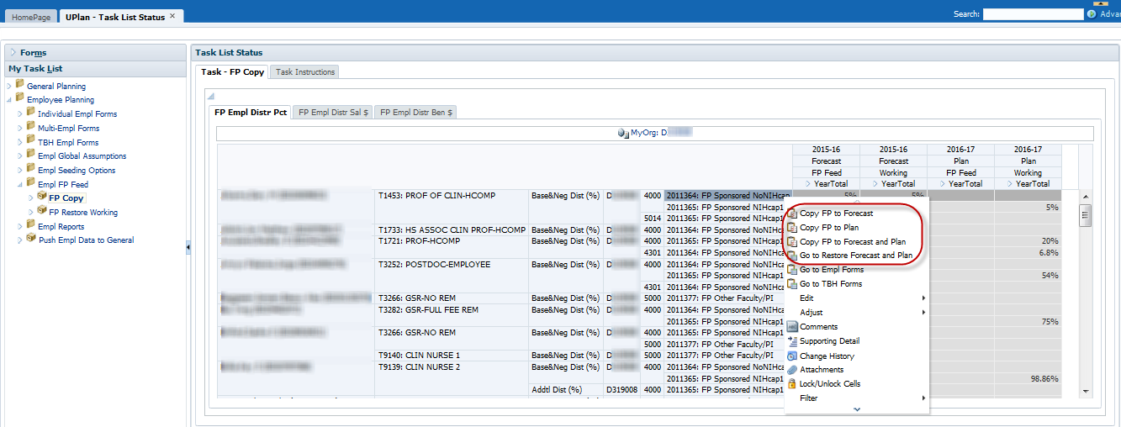
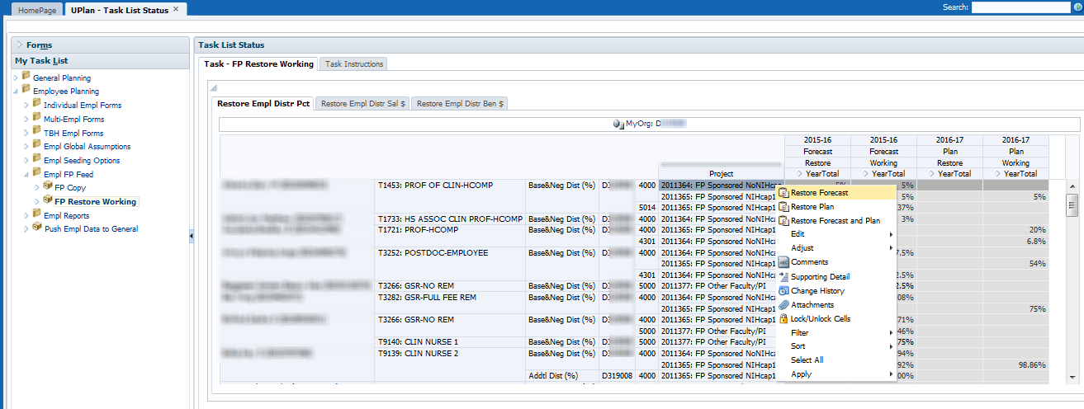

7.0 Employee Planning Form Reports
All Employee Planning Reports are Form Reports. These are diagnostic reports that help you view employee salary plans and distribution information. There are currently two reports available
- The Compensation Detail by DFP shows the details of employees funded by a specific DFP. This form can be accessed under Employee Planning>Empl Reports or can be navigated to from the Revenue and Expense forms in General Planning via the right-click menu.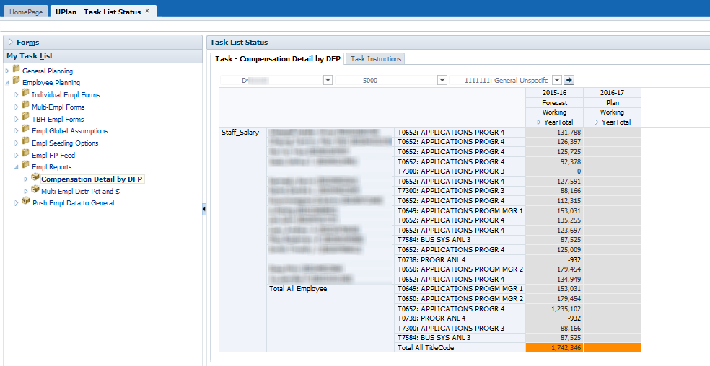

- The Multi-Empl Distr Pct and $ shows the funding DFP distribution percentages and calculated distribution dollars for salary and benefits under the selected MyOrg DeptID. 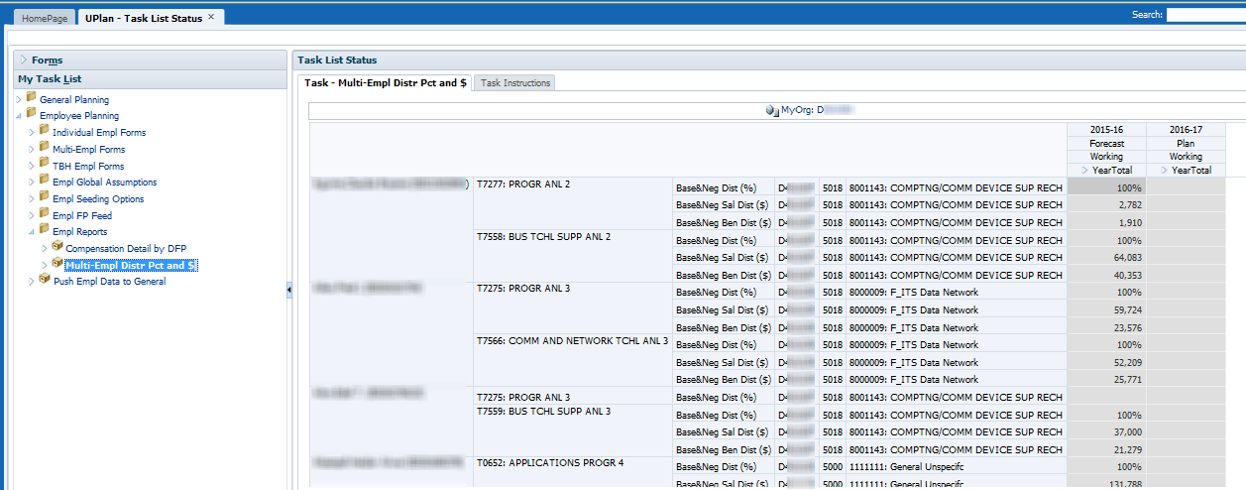

8.0 Other Employee Planning Topics
This section discusses several other topics in Employee Planning. It also covers variations in planning by employee type and some special situations, and using salary and benefit adjustments account in General Planning.

8.1 Handling Special Situations

Multiple Title Codes
Employees with multiple title codes will appear on multiple rows on all forms. Planners will need to create salary and benefit plans for each title code.

Medical Center Employees
Only employees with a campus home department (non-medical center) will appear in UPlan; employees with a medical center home department will not appear in UPlan. In addition, distributions for employees with a campus home department but which are funded by the medical center will not appear in UPlan.
- You will use Employee Planning to plan for non-medical center employees of the campus, e.g., those with a campus home department.
- For employees with a medical center home department, but who are paid at least in part by a campus unit, planners will need to add the individual as a TBH employee.
- If an employee is owned by a campus home department, he/she will appear on the roster for that home department and the campus departments providing pay for that employee will enter their appropriate share. The portion of their salary funded by the medical center will not be included in UPlan. The home department need not worry about the medical center portion of the salary and benefits.
- Employees with a medical center home department will not appear in UPlan. For employees with a medical center home department but are fully or partially paid by a campus department, the paying department will need to create a TBH provision and enter the appropriate salary and pay distribution percentage. No special functionality is required.

Benefits for Fellows and Residents with No Salary (pending changes)
Postdoctoral fellows or other employees who have no salary, but do have benefits costs paid by UCSF will appear in the Employee Planning module. Planners will need to manually adjust benefits levels and distributions. Alternatively, planners can create a TBH provision with zero salary and manually benefits and distributions. A second alternative is to make adjustments in the General Planning module.
The healthcare benefits for Fellows and Residents that are paid directly by the campus (i.e. HR) to a third party insurance company will be planned in the General Planning cube. There are some benefits costs that go through payroll and reported as benefits costs, but these healthcare costs are reported under a non-benefits expense account which rolls up to Level E Account “5577E-Other services” which in turn rolls up to Level C Account “5550C-Services”. Departments with these types of benefit costs should plan for them in the Revenue & Expense form in the General Planning module.

8.2 Adjusting Planned Salary and Benefits in General Planning
If your department or Control Point does not require detailed salary and benefit expense information, you can use the Revenue & Expense form in the General Planning Module to forecast or plan.
You may also want to perform the majority of your salary and expense planning within Employee Planning but still use the General Planning module for related adjustments.
Keep in mind that when you use the Revenue & Expense form, you will work with DFP combinations.
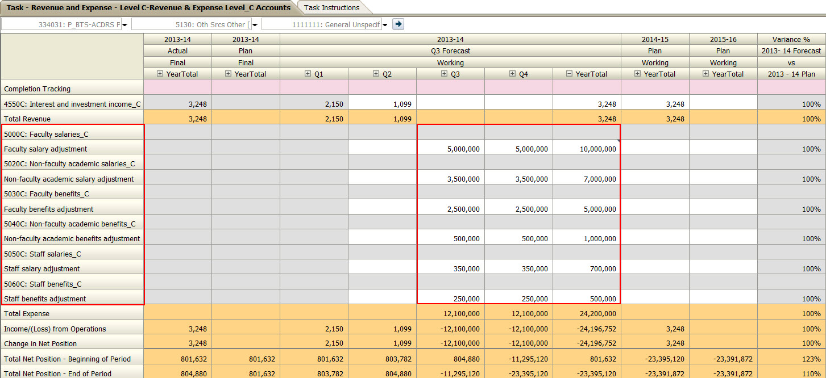
There are fourteen accounts related to salary and benefit expenses in the Level C-Revenue and Expense form. Seven Level C accounts are from the Chart of Accounts and are read-only, numbered accounts that pull plan data from Employee Planning (note that actuals are fed from PeopleSoft GL). The other seven accounts are planning account only and are writable, non-numbered accounts where you can input salary or benefit adjustments against the Level C accounts plan amounts.

