UPlan

For more information, visit
https://brm.ucsf.edu/uplan

Spring 2021

Commitment Tracking

© [2020-2021] “University of California San Francisco (UCSF)”
Ownership of Copyright
The copyright in this material (including without limitation the text, artwork, photographs, and images) are owned by UCSF.
Copyright License
UCSF grants to you a non-exclusive royalty-free revocable license to:
- View this material on a computer
- Store this course in your cache or memory
- Print pages or material from this course for your own personal and non-commercial use.
All rights reserved.
Enforcement of Copyright
UCSF takes the protection of its copyright very seriously. If UCSF discovers that copyrighted materials have been used in contravention of the license above, UCSF may bring legal proceedings against you seeking monetary damages and an injunction to stop you from using the materials.
Contents
Commitment Tracking Overview 6
What are Commitments? 6
Recurring allocations 6
Temporary allocations 6
Commitment Tracking Dimensions 7
Recommended Fields 9
Commitment 10
Distribution 10
Source and Target DeptID 10
Transfer Type 10
Fund 11
Fund Mapping for Transfers to Plant 12
Source and Target Project 12
Year and Period 12
Short Description and Long Description 13
Start Date and End Date 13
Approval Date 13
Additional Dimensions and Characteristics 13
Requestor, Authorizer, and Date of Request 13
Status 13
Duration 13
Purpose 14
Contingency 14
Transfer Out $ and Transfer In $ 14
Commitment Tracking Forms 15
Manage Commitments Landing Page 16
POV: MyOrg 17
Commitments Search 17
Commitment Form 18
Commitment Form Top Panel: Characteristics 19
Commitment Form Bottom Panel: Transfer Out Amounts 19
Adding and Editing Commitments and Distributions 20
Editing Existing Commitment 20
Adding a New Commitment 23
Adding a New Distribution 24
Deleting a Commitment 24
Deleting a Distribution 25
Commitment Tracking Topics 27
Integration with General Planning 27
Seeding Future Commitments Plans 27
Cascading Commitments 27
Commitment Reports 28
Commitment Form Reports 28
By Source DeptID 28
By Target DeptID 29
Commitment Hyperion FR Reports 29
Commitments by Source - Summary 30
Commitments by Source and Year – Detail 30
Commitments by Source and Month – Detail 30
Commitments by Target – Summary 30
Commitments by Target and Year – detail 30
Commitments by Target and Month – Detail 30

Commitment Tracking Overview
This document discusses the Commitment Tracking module and covers the concepts associated with planning and forecasting of transfers and allocations, and their integration with General Planning. By the end of this document, you should be able to:
- Understand the Commitment Tracking module
- Become familiar with data elements associated with Commitment Tracking
- Use the Manage Commitments and Commitments forms
- Add, edit, and delete commitments and distributions
- Know how Commitment Tracking integrates with General Planning
- Run Commitment Tracking reports
Commitment Tracking is a module within UPlan where you can plan financial transfers.
To use the Commitment Tracking module, you will access the CommtPln application from the HomePage of UPlan.
You can plan commitments for a timeframe that includes the current year and ten future years. UPlan will feed this data to General Planning for Current Year and Years 1 and 2 and show commitments as transfers from the source DeptID to the target DeptID. This allows recipients to plan expenses against commitments.
You can also run reports to analyze the commitments for which you are the source or view details about commitment distributions for which you are a target department (that is, the recipient).

What are Commitments?
Commitments are essentially planned financial transfers. Commitments comprise two types of allocations or financial transfers:

Recurring allocations
Ongoing distributions of funding from the Chancellor or Control Points to individual units. They may or may not be tied to specific uses beyond the general missions of UCSF. In many cases, these recurring allocations were maintained in the permanent budget prior to UPlan.

Temporary allocations
Promises to provide funding for specific activities. Prior to the UPlan implementation at UCSF, Control Points and departments have used a variety of methods for tracking commitments.
Generally, commitments are based on a negotiated agreement between Source and Target departments. The means of negotiation include budget processes, hiring packages, executive meetings, hallway conversations, etc. Discussions include what activities will be funded, at what amount, and upon what contingencies. In the case of recurring allocations, the amount of negotiation may be very limited.
The means of documentation include budget allocation letters, appointment letters, e-mails, handwritten meeting notes, verbal communications, etc.
Activities funded from commitments include (but are not limited to) faculty hires, new programs, capital projects, research support, subsidies for initiatives, financial aid, intra-departmental shared resources, (a single commitment could include all of the above), or payment of assessments (e.g., UCOP assessment, Dean’s Tax).
Commitments can include negative commitments. In a negative commitment, negative “transfer in” dollar amounts represent funding owed to the initiator (aka, source department) by the recipient (aka target). Examples of negative commitments are the UCOP Assessment and Dean’s Tax.
A commitment typically includes:
- Source and Target DeptID (could be the same)
- Source and Target Projects (could be the same)
- Fund
- Amount
- Start and End Dates
- Duration (Temporary or Recurring)
- Purpose (e.g., start-up, deficit coverage, etc.)
- Approval Dates
- Individual commitments in UPlan may include multiple distributions. This concept will be explained in more detail later in this lesson.

Commitment Tracking Dimensions
There are several data fields in the Commitment Tracking module. Some of these correspond to dimensions, while others are informational. The table below describes each data field:
Members | Type | Requirement | Description
Commitment (CmtXXXXX) | Number | Required | Automatically generated when you add a commitment
Distribution (DistXX) | Number | Required | Automatically generated when you add a distribution
Source DeptID | List | Required | Initiator department of commitment and provider of funding
Target DeptID | List | Recommended | Recipient department of commitment funding
Source Project | List | Recommended | Source project of commitment funding
Target Project | List | Recommended | Recipient project of commitment funding
Function | List | Optional | UC Function Code
Fund | List | Recommended | Type of funding committed
Short Description | Text | Optional | Description of the commitment
Long Description | Text | Optional | Description of the commitment.
Transfer Type | List | Recommended | Type of commitment, helps determine the appropriate Account value.
Purpose | List | Optional | Purpose of commitment, for reporting.
Duration | List | Optional | Whether commitment is temporary or recurring.
Status | List | Optional | Indicates whether commitments is new, ongoing, anticipated, or completed.
Start Date | Date | Optional | The start date of the commitment or allocation. No functionality, only for reference.
End Date | Date | Trigger | The end date of the commitment or allocation. This date will be used for knowing whether a commitment or allocation should “roll” to a new fiscal year as they are added. The actual day of the month will not be relevant.
Contingent | List | Optional | Yes/No values. Used to indicate whether a commitment has contingencies.
Requestor | Text | Optional | Name of the person who requested the commitment.
Date of Request | Date | Optional | The date that the commitment or allocation was requested. This field will most likely contain a different date than the start date.
Authorizer | Text | Optional | The name of the person that approved/ authorized the commitment or allocation.
Approval Date | Date | Trigger | The date that the commitment or allocation was approved. Commitments with no approval date will be visible to the Target in the Commitment Reporting module, but will not appear as a transfer in the General Planning module. They will be visible to the Source DeptID in both places.
Transfer Out $ | Number | Recommended | Planned dollar amounts by month and year.
For a number of fields, planners can simply type information directly in the cell. These fields include the Short and Long Descriptions, the transfer amount fields, and several others.
Some fields have special drop down options called Smart Lists. These include:
- Source DeptID
- Target DeptID
- Fund
- Transfer Type
- Purpose
- Duration
- Status
- Function
To select a value for one of these fields, click the down arrow to bring up the Smart List. You may type the ID or part of the description to help find your selection.
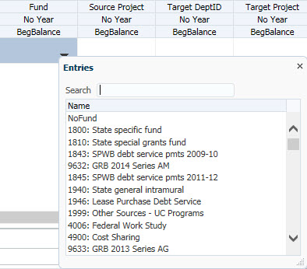
Note: If you are unable to see the down arrow in order to change the selected value, first widen the column until the down arrow appears.

Recommended Fields
As you work with Commitments, there are certain fields that are not required, but are strongly recommended:
- Source DeptID
- Fund
- Source Project
- Target DeptID*
- Target Project
- Transfer Type*
- Approval Date*
- Transfer Out $ (for at least one year)
When you create a commitment and it has a Source DeptID, it will flow into General Planning. Completing these fields will ensure that a commitment flows to the correct Source and Target DFP combinations. If you do not include Fund and Project information for example, the commitment may appear in NoFund or NoProject. As long as you have all the recommended fields entered, the data will show in General Planning for both the Source and Target DeptID. Note that there can be up to a one-hour lag between saving the data in Commitment Tracking and it flowing to General Planning.
If you leave out the Approval Date, the data will appear in the General Planning module in the Source DeptID as a negative transfer. However, it will not appear in the General Planning module in the Target DeptID as a positive transfer. (The Target DeptID would still see the commitment in Commitment Tracking reports.)

Commitment
All UPlan users share the same pool of Commitment Numbers. UPlan will generate a unique Commitment Number sequentially for each new commitment entered by any user. Commitment format is Cmt000001, Cmt000002, etc.
Commitment numbers are recycled. If another user deletes a commitment, then the next user to “Add a Commitment” will get the lowest Cmt# in sequential numeric order. Also, note that commitments do not populate the Landing Page by the date the commitment was added but rather by Cmt#. The Landing Page list of commitments is not in chronological order.

Distribution
The Distribution dimension identifies up to 99 individual distributions (Transfers Out) within a commitment. Each Commitment will have at least one Distribution. When you add a new Commitment, it automatically generates Dist01. (If you need additional distributions for the same commitment, you can add them, and they will be numbered sequentially Dist02, Dist03, etc.). You will identify the characteristics of this distribution when you edit the commitment itself. To Add a Distribution, you will use the right click menu.

Source and Target DeptID
Each commitment has a Source DeptID and a Target DeptID. The DeptID dimension is essentially the same for Commitment Tracking as in General Planning. However, in the Commitment form, a placeholder named ”Unspecified DeptID” is available for commitments that are being planned but for which the specific source or target DeptID is unknown at the time of initial planning.
It is possible for the Source DeptID and Target DeptID to be the same; in these cases, presumably the Source Project and Target Project are different.

Transfer Type
Transfer Type describes the commitment, and is used along with the Fund value, to map Commitment Distributions to the appropriate “Transfer” Account in the General Planning module.
Transfer Type has the following values:
Transfer Types
No Transfer Type
MC-PSA
MC Purchased Svcs
MC Strategic Suppt
Other Clinical
Affiliation and Contract
Recharge Transfer
Costed Central Activity Transfer
Patent Income
Investment Income Transfer
Deficit Support
Dean’s Support
VC Support
Profit Sharing
Other Support Transfer
Transfer betw Funds
Transfer to FFE
Transfer to Plant
STIP Transfer
Debt Service
Department Assessment
Dean or Control Point Assessment
Chancellor Assessment
Allocations and Other Operating Transfers
Each of these transfer types correspond to a revenue account (except in the case of the “Allocations and Other Operating Transfers”).
Note: If the Commitment is a placeholder, you can leave this field blank and it will default to No Transfer Type.

Fund
With the exception of commitments with Transfer Type equal to “Transfer to Plant”, Fund will be the same for both the Source and Target.
Sponsored funds are not included in the Commitments module. The following sponsored research funds are not available in the Commitment module (and will not appear on the Fund Smart list):

Excluded Funds
4000 | Federal Gv Grant
4001 | Federal Gv Contract
4002 | Federal Gv Coop Agreement
4003 | Federal Gv Grant, ARRA
4004 | Federal Gv Contract, ARRA
4005 | Federal Appropriations-ARRA
1940 | State general intramural
4100 | State Gv Contract, Grant, Coop
4200 | Local Gv Contract, Grant, Coop
4300 | Private Grant
4301 | Private Contract
4400 | Clinical Drug Trial
1800 | State specific fund
1810 | State special grants fund

Fund Mapping for Transfers to Plant
For Transfers to Plant, in most cases, the Source Fund will be a Current Fund. Fund will be as entered for the Source, but internal system logic will map the Current Fund to a Plant Fund for the Target as follows:
Source Fund | Target Fund
7000 Private Restricted Gifts | 9000 Unexp plant restr gift fund
7100 Private Unrestricted Gifts | 9100 Unexp plant unrestr gift fund
Other Current Funds (under 100A) | 9105 Unexp plan university funds
9XXX Plant Fund | Value is the same as the Source

Source and Target Project
Each commitment has a Source Project and a Target Project. It is possible for the Source Project and Target Project to be the same; in these cases, presumably the Source DeptID and Target DeptID are different.
While Faculty Recruitment, Faculty Retention and Other Faculty/PI projects will be aggregated to the planning-only Project Use level in General Planning, transfers to and from specific projects in these areas can be planned in the Commitment Tracking module. Users can make commitments to specific Project IDs for any of these three Project Uses. The commitment data, however, will be aggregated to the corresponding “FP” planning project in General for both the target and source. Because revenue amounts for sponsored projects are automatically calculated in the General Planning module, sponsored projects (real and planning-only) will not be used in the Commitment Tracking module.

Year and Period
Year is the same as in General Planning, except that there are 11 years available for planning in the Commitment Tracking module: current year and ten years from the current year. You will enter data for Years as part of Transfer Out $ fields on the bottom half of the Commitment form. For the current year and Plan Year 1, commitments can be planned at the month level, while planning for Years 2-10 is at the YearTotal level.
As the years shift, users will need to revise their Plan Year 1 from the year total to monthly planning to follow the planned schedule of actual financial transfers.

Short Description and Long Description
The Commitment form provides fields for both a short description and a long description. The short description will appear on most Commitment Reports, and also on the Manage Commitments form. Users should use short descriptions that will allow for a clear understanding of the specific commitment in a way that can be sorted with other commitments. You can use Long Description for recording information that does not fit into another field.

Start Date and End Date
Start Date and End Date are provided to store background information about a commitment. They are not required. Start Date has no functional impact.
End Date does have a functional impact; it is used only to determine whether a new Year 10 amount should be populated when the module is updated for the new year. Type a date in the format M/D/YYYY (such as 1/1/2021 or 12/31/2021) or use the calendar lookup provided.

Approval Date
In order for information about a commitment to flow to General Planning forms for a Target DFP, the Approval Date must be completed. Type a date in the format M/D/YYYY (such as 1/1/2021 or 12/31/2020) or use the calendar lookup provided.

Additional Dimensions and Characteristics
The following fields are all optional. No functionality depends on these fields. If you leave one of them blank, it will default to a generic selection called NoXxxx (such as NoPurpose).

Requestor, Authorizer, and Date of Request
These fields are provided to store background information about a commitment. They are not required and have no functional impact. For Requestor and Authorizer, type any text you would like. For Date of Request, type a date in the format M/D/YYYY (such as 1/1/2021 or 12/31/20) or use the calendar lookup provided.

Status
Status indicates where a commitment is in the process.
Member
Anticipated
New
Active
Completed
NoStatus

Duration
Use the optional Duration field to differentiate temporary and recurring allocations.

Purpose
Helps describe the commitment and may be useful for aggregating, grouping or selecting commitments for reporting.
Purpose Member
Facilities - Debt Service
Facilities - Capital Projects Programmatic/Seismic
Facilities - Scheduled Renewal Projects
Facilities - Investment Projects
Facilities - Remediation Projects
Capital Leases
Technology
Strategic Initiatives/Projects
Program Support
Loan
Internal Loan - Mid-Career Recruitments
Internal Loan - Business Plan Loans
Operational - Emergency Operational Assistance
Operational Utilities
Operational - UCOP
Operational - Undesignated
Discretionary
Intra-Departmental Expenses-sharing
Research Support
Salary Support
Education
Administration
Bridge Funding
Operational - Pooled Costs
Operational - F&A Allocations
Miscellaneous
Internal Loan - Other
Operational - Temporary
Flow-Through Recurring
Initiatives - UCOP
State Educational Appropriations Allocations
State Utilities Allocations
State Appropriation - SAPEP Allocations
State Research Appropriations (QB3) Allocations
Lottery Funds Allocations
Financial Aid Allocations
F&A Allocations to Schools
Patent Fund Allocations to Schools
Rate Additive Allocations
Campus Support Fund Allocations
State Educational Appropriations
State Tobacco Tax
State Appropriation - SAPEP
Lottery Funds
Tuition
Nonresident Supplemental Tuition
Application Fee
F&A Cost Recovery
Patent Earnings
STIP Earnings
STIP Cap Earnings
TRIP Earnings
Foundation Investment Earnings
Legal Recovery (includes Remediation Recovery)
Miscellaneous Revenue
Rate Additive
Endowment Cost Recovery
Gift Fees
UCSF Health Recharge for Debt Payments
UCSF Health Strategic Revenue
UCSF Health Annual Operating Support
FFE Income (19A-Neurosciences)
FFE Income (17A/B-CVRB)
FFE Income (PCMB)
Century Bond Drawdown
Control Point Share of UCOP Assessment
UCSF Health Ground Lease Revenue
Endowment Transfers
Facilities - Auxiliary Projects
Facilities - FIN Projects
Facilities - Leases and Other
Facilities - Operating Costs
Facilities - Program Projects
Facilities - Renewal Projects
Facilities - Seismic Projects
Facilities - Studies Projects
Initiatives - Faculty Support
Initiatives - SIF
Initiatives - Technology
Operational - Academic Programs
Operational - Faculty Support
Operational - Administrative
Operational - Other OMP
Placeholders
Placeholders - Renewal
NoPurpose

Contingency
The contingency field is provided to allow users to track commitments that require some condition before funds are transferred. Acceptable values are Yes or No. There is no functional impact of this field, but it will appear on certain reports.

Function
The function code field is provided to allow users to track which function it will hit when the actual journal is prepared and recorded.

Transfer Out $ and Transfer In $
The Transfer Out $ fields capture the dollar amounts associated with planned commitments, as entered by the Source DeptID. The Transfer In $ fields capture the amounts for the Target DeptID. Values may be entered at the monthly or YearTotal level for Year 0 and Year 1, but only at the YearTotal level for Years 2-11.

Signage
In reports, a planned transfer of funds from the Source DeptID will appear as a negative value, while it will appearas a positive value for the Target DeptID. However, when entering data in the Commitment Tracking module, planners for the Source DeptID should enter a positive value when they are planning to transfer money away.
Source DeptID is: | Landing Page and Reports | Data Entry Form
Giving money away | – | +
Taking money back | + | –
Target DeptID is: | Reports*
Losing money | –
Receiving money | +

Spreading Transfer Out Dollars across Months
As mentioned above, data can be entered and stored at the monthly level for Year 0 (the current year) and Year 1 (next year). For the current year forecast and next year’s plan, in order to avoid odd variances in forecasts, users should make sure to distribute the money exactly as it will be transferred in financial journals. For example, if the entire commitment will be transferred in July, then do not enter the amount in YearTotal; enter the amount in July only. Also, remember that a commitment in UPlan does not replace the financial journal. Users will still need to complete financial journals separately and outside of UPlan.
When the timing of the actual transfer varies from the commitment schedule, the forecast will be incorrect. In these instances, planners can simply adjust the corresponding revenue account in the forecast to make up for the variance between transfer and commitment schedules. Alternatively, planners can adjust (or ask the Source DeptID planner to adjust) the planned distribution in the Commitment Tracking module.

Commitment Tracking Forms
The Commitment Tracking module includes three forms:
- Manage Commitments
- Commitments Search
- Commitments
The Manage Commitments form is a Landing Page form in the Commitment Tracking module, allowing planners to view summary information for all commitments within a MyOrg selection and use it as a launch pad. From this landing page, you can add commitments or distributions, delete commitments, or access a specific commitment in order to make adjustments. It is the only form where you can delete a commitment.
The Commitments Search form is another Landing Page, providing a view of a single commitment. Planners can also open the Commitment data entry form from the Search Commitments form.

Manage Commitments Landing Page
The Manage Commitments form is the “command central” of the Commitment Tracking module. You will use it to view a summary of your current commitments to other departments and to launch various actions to add, delete, or edit commitments.
After you have set your MyOrg DeptID, open the Manage Commitments Landing Page form. (If you try to open the form before setting the MyOrg variable, you will see an error message.) The Manage Commitments Landing Page shows the list of commitments and associated distributions for which the user’s DeptIDs are the Source DeptID.
Because the Manage Commitments form is a Landing Page, all cells are gray. No information can be entered or edited from this form. Here is a summary of the Manage Commitments form layout:
- Point of View (POV): MyOrg DeptID setting
- Rows: Commitments, Distributions and Source DeptIDs
- Columns: Short Description, Target DeptID and Transfer Out Dollars for eleven years
For more details on each of these fields, see the Data Elements section of this lesson.
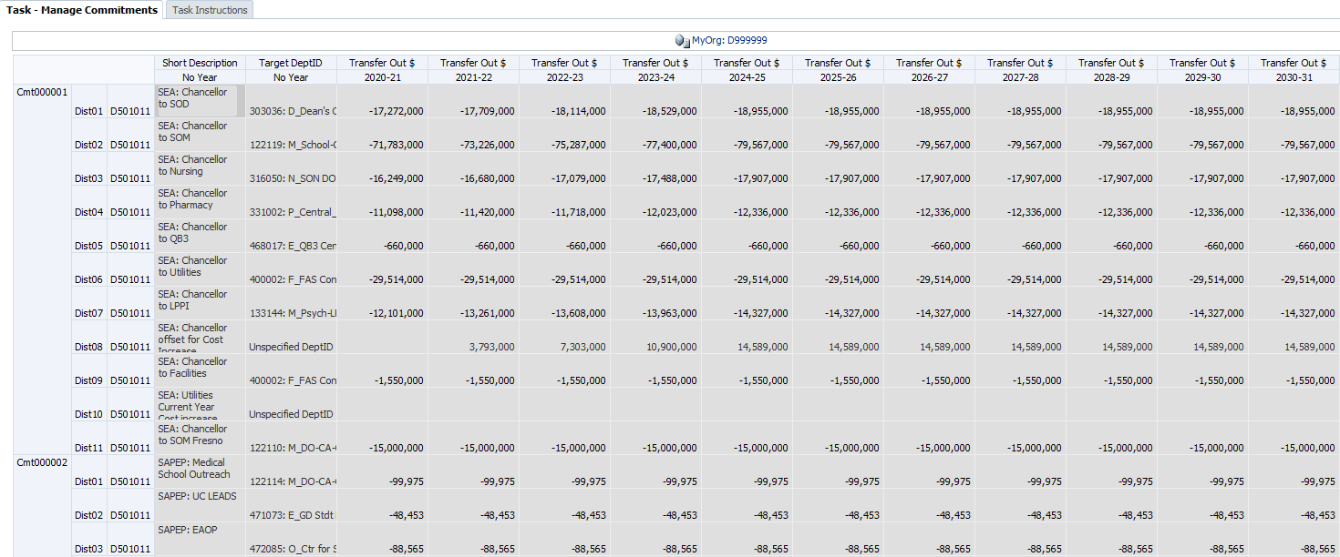
The Manage Commitments Landing Page right-click menu options include:
- Add a Commitment
- Add a Distribution
- Edit Existing Commitment
- Delete Commitment
These selections will be discussed later in this lesson.

POV: MyOrg
The Point of View, at the top of the form, shows the selection for MyOrg. This is the DeptID you selected initially in the Preferences > User Variable screen. The commitments that display on the Manage Commitments form relate to this DeptID.
- If you selected a planning DeptID as your MyOrg, then only the commitments for that DeptID will appear.
- If you selected a higher-level DeptID, then the commitments for any DeptIDs below this MyOrg choice appear.
You can change the list of DeptIDs that are included by changing MyOrg again. After its initial setup, you can change the MyOrg selection directly from the Manage Commitments Form. You simply click on the MyOrg link at the top of the form and select a new DeptID from the member selection dialog box.
Note: Remember that Commitment Tracking is where you plan for transfers for which you are the Source – you are planning to transfer funds to another (Target) DeptID.

Commitments Search
The Commitments Search form provides speedier access to a specific commitment if you know the Commitment Number, which can be changed in the Page Filter. From this form, you can launch various actions to add a distribution or edit commitments.
The Commitments Search Landing Page right-click menu options include:
- Add a Distribution
- Edit Existing Commitment

Commitment Form
The Commitment Data Entry Form allows users to make adjustments to all distributions within a commitment. From the landing page, when you right click a commitment and select Edit Existing Commitment, the Commitment form appears, displaying the Source DeptID and the Commitment number in the POV.
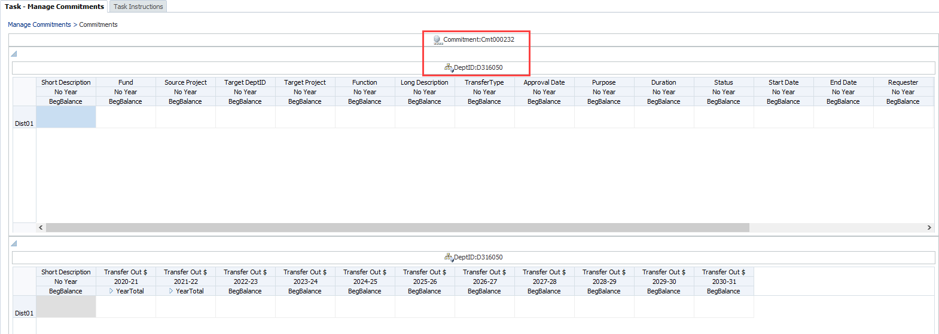
The Commitment form is really a “composite form,” of two forms displayed as upper and lower panels, designed to reduce the amount of left-to-right scrolling.
- In the upper panel, columns include all commitment characteristics.
- In the lower panel, columns include the commitment dollar amounts by year. These are called Transfer Out Dollars. The first two years, (currently 2020-21 and 2021-22), can be planned at the month level. Later years can only be planned on an annual basis. Also, the short description is shown on both the upper and lower panels, but can only be edited in the upper panel.
- For both panels, the user can scroll left and right or up and down as needed.
Rows are all of the distributions for the commitment. Users may add or edit values for multiple distributions before saving. The right-click menu allows for distributions to be added or deleted.
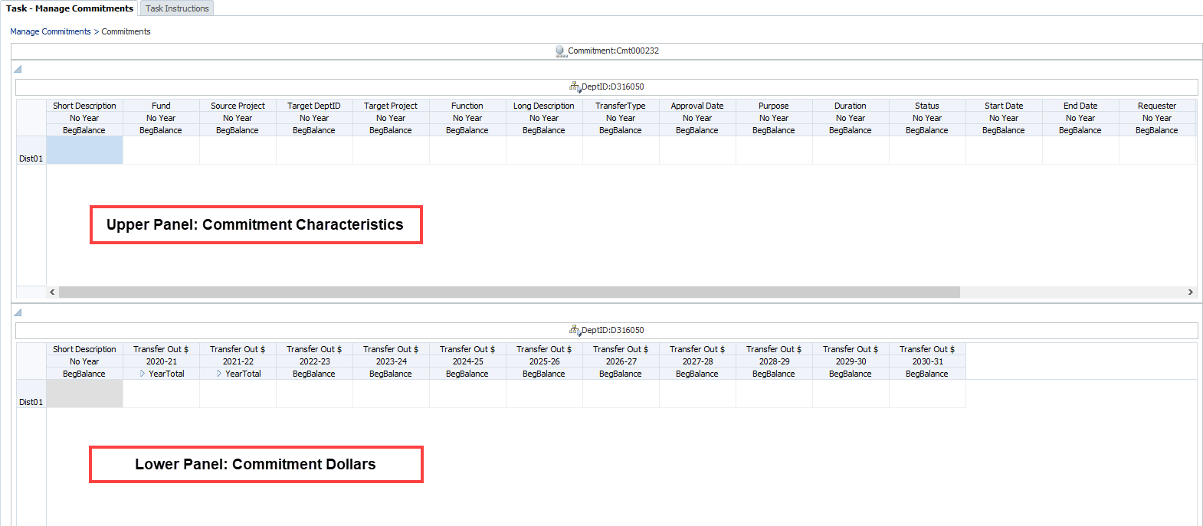

Commitment Form Top Panel: Characteristics
The top half of the Commitment form includes informational data element fields. All but one of the recommended fields are found here. For more details, see the Recommended Fields section.
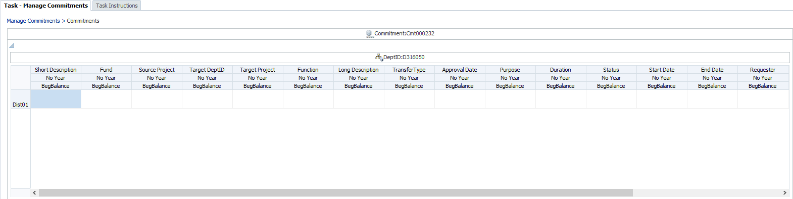

Commitment Form Bottom Panel: Transfer Out Amounts
The bottom half of the Commitment form is for the dollar amounts you are transferring in a given year. You must enter at least one Transfer Out $ field.
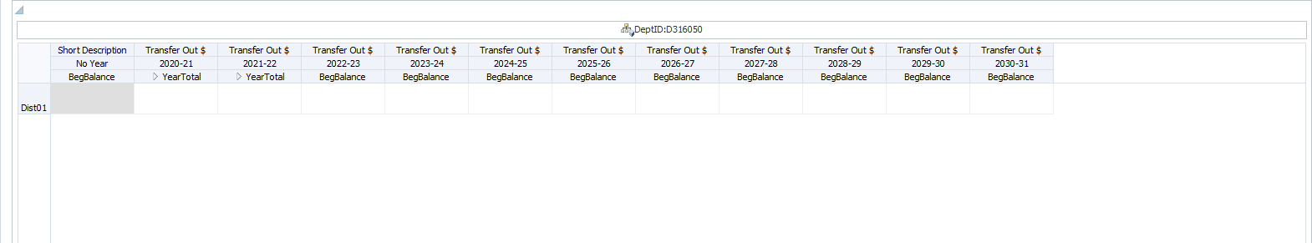

Adding and Editing Commitments and Distributions
You use the right-click menu to enter and edit information and data in Commitment Tracking. Here are the key options:
- Add a Commitment
- Add a Distribution
- Edit Existing Commitment
- Delete Commitment
When you are adding a commitment or a distribution for a commitment, UPlan will add this to the Manage Commitments form. Once you have added them, to actually enter data elements for these commitments, you will be using the Edit Existing Commitment option.
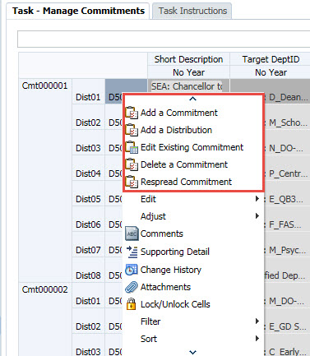

Editing Existing Commitment
Use Edit Existing Commitment to change a saved commitment with information and to populate fields for a newly added commitment or distribution.
To Edit an Existing Commitment
- Go to the row for the Commitment Number and Distribution Number you want to edit.
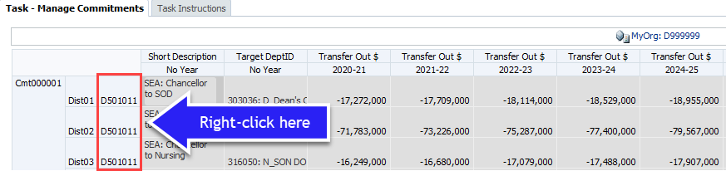
- Right click on the source DeptID and select Edit Existing Commitment.
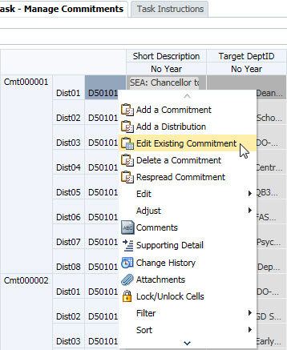
The Commitments form opens with information for this Commitment Number displaying.
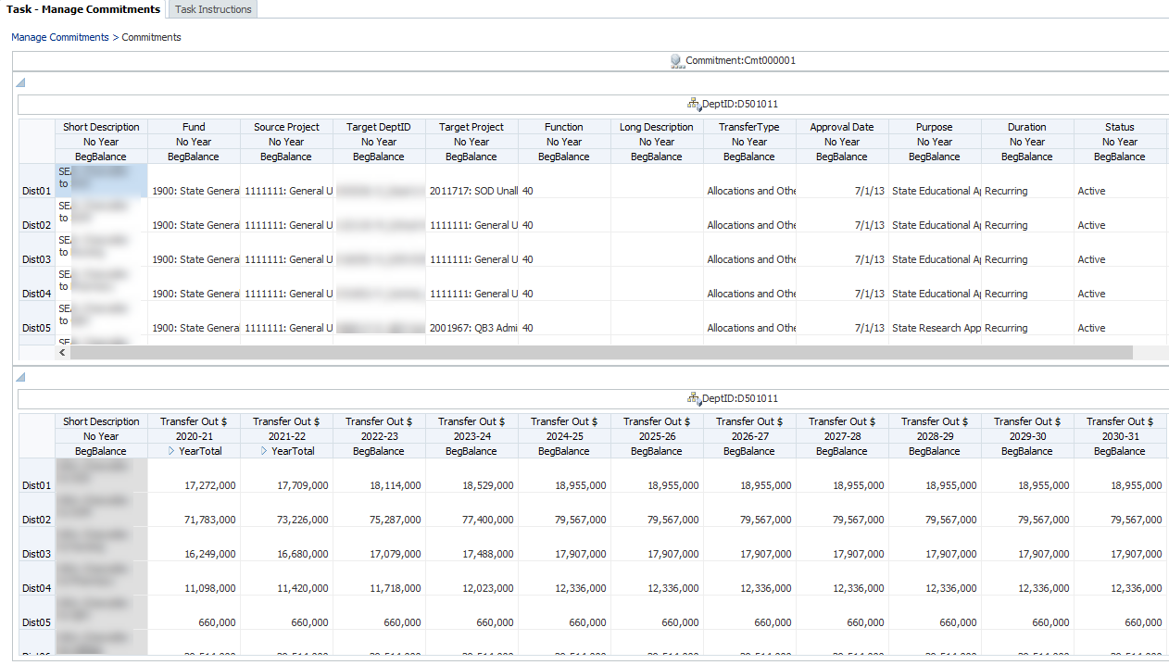
- On the Commitments form, make any changes you need on the top panel to any of the data element fields. For items with a Smart List (indicated by a down pointing triangle), select a choice from the list provided.
Note: If this is a newly added commitment or distribution, complete all the recommended fields to ensure that the planned transfer flows properly to the General Planning module:
- Source DeptID
- Fund
- Source Project
- Target DeptID
- Target Project
- Transfer Type
- Approval Date
- Make any changes you need on the bottom panel to Transfer Out $ amounts.
- For the Year 0 and Year 1, make sure to distribute the money to match the month that you will schedule the associated PeopleSoft financial journal to actually transfer the commitment amount. For example, if the entire commitment will be given in July, then input it in July only. Do not input it in YearTotal.
- Remember that this does not replace your financial journal. You will still need to enter that separately.
- Enter Transfer Out $ for up to nine more years. For Year 2 and beyond, enter annualized values.
- Save after making changes or periodically using Ctrl +S or the Save icon.
- To return to the Manage Commitments form, click the Manage Commitments link at the top of the form.
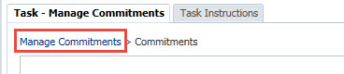
The Commitment you entered will appear on the Landing Page for the Source DeptID with the signs of the dollar amounts reversed. (Example: if you enter positive transfer dollars, the amount will show as negative, meaning you are transferring funds away.)
Note: You will only see the commitment on the Landing Page for the Source DeptID. The commitment will not show on the Landing Page for the Target DeptID. To see the commitment from the Target DeptID perspective, you would run a Hyperion Report.

Adding a New Commitment
When you add a new commitment, it will be assigned a Commitment number automatically. Let’s review how this works.
UPlan will generate a unique Commitment number sequentially for each new commitment entered by any user. Commitment format is Cmt000001, Cmt000002, etc.
Commitment numbers are recycled. If another user deletes a commitment, then the next user to “Add a Commitment” will get the lowest CmtXXXXX in sequential numeric order. Also, note that commitments do not populate the Landing Page by the date the commitment was added, but by Cmt#. A Landing Page list of commitments is in numerical order by Cmt#, not in chronological order it was created, and so it might not appear at the bottom of the Landing Page. Therefore, before you add a commitment, take a good look at your Landing Page. After you add the commitment, you should see a new CmtXXXXX with blank fields after the DeptID:
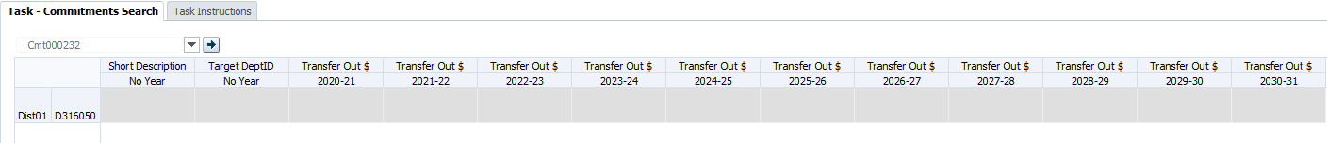
After you add the new commitment, you will use Edit Existing Commitment to enter the information.
To add a new commitment:
- Begin with the Manage Commitments form.
- In the rows, right click on any source DeptID and select Add a Commitment.
The Add Commitment prompt appears.
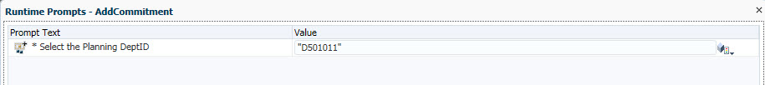
- Type or select the DeptID that will be the Source DeptID of this commitment. If you type it, make sure to use the letter D before the DeptID number. To select, click the Member Selector icon and use the Member Selection dialog box to search and select a Source DeptID.
The new Commitment number appears on the Manage Commitments form, with an automatically-generated member name in the format Cmt000### and Dist01 automatically created.
- Right-click on the DeptID for the new commitment and select Edit Existing Commitment. Follow the steps outlined earlier to complete data entry for the commitment.

Adding a New Distribution
You can add a new distribution from either of the two forms: Manage Commitments or Commitment form. The new distribution ID will be sequential. For example, the first time you add a new distribution, it will be Dist02. (Dist01 is always created when you add a new commitment.)
To add a new distribution:
- Use the right click menu on either the Manage Commitments or Commitment form:
- From the Manage Commitments form, go to the row for the Commitment you want
- From the Commitment form, go to any row
- Right click on the source DeptID for which you want to add a distribution and select Add a Distribution.
- The new Distribution is added below the last distribution in this Commitment, with the next consecutive distribution number.
- If you added the Distribution from the Manage Commitments menu, right click the DeptID next to this new distribution and select Edit Existing Commitment, which will result in the Commitments form appearing. If you added the Distribution from the Commitments form itself, you can begin entering data immediately Follow the steps outlined earlier to complete data entry for the commitment.

Deleting a Commitment
If you discover that you no longer need a commitment, you can delete it from the form. All of the distributions associated with it will be removed as well. The change will also flow through to General Planning.
To delete a commitment:
- Go to the row for the Commitment Number and Distribution Number you want to edit.
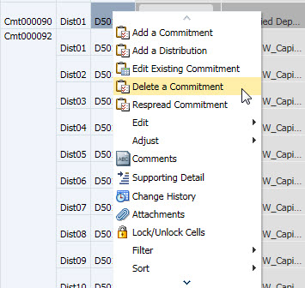
- Right click on the source DeptID and select Delete Commitment.
A prompt appears, warning that the commitment and all its distributions will be permanently deleted.
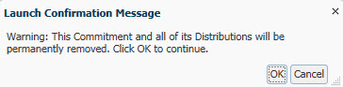
- Click OK.
A message confirms the deletion, and the commitment and any associated distributions are removed from the Manage Commitments form.
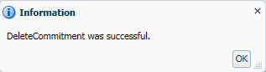
- Click OK.

Deleting a Distribution
You can delete a distribution from the Commitment form. This can be useful if one distribution within a commitment is no longer needed. You can only delete a distribution from the Commitment form itself, not from the Manage Commitments Landing Page.
To delete a distribution:
- From within a Commitment form, go to the row for the Commitment Number and Distribution Number you want to edit. (If you are on the Manage Commitments Landing Page, right click the DeptID for the Commitment that holds the Distribution you want to delete and select Edit Existing Commitment.)
- Right click on the source DeptID and select Delete a Distribution.
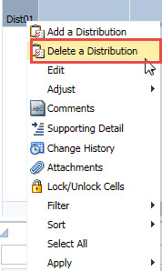
- A prompt appears, warning that the commitment and all its distributions will be permanently deleted.
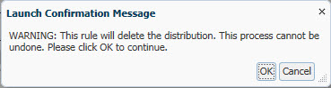
- Click OK.
A message confirms the deletion, and the commitment and any associated distributions are removed from the Manage Commitments form.
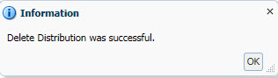
- Click OK.
Note that every commitment must have a “Distribution 1”, therefore deleting Dist01 will delete its content but not the placeholder for Dist01. Use the steps above to clear the content only from Dist01. You can also cut/paste content from another Distribution into Dist01 to effectively modify/delete Dist01.

Commitment Tracking Topics

Integration with General Planning
Three years (current year plus two planning years) of commitment data from the most recent plan/forecast will flow from Commitment Tracking into the existing dimensions in General Planning. These will be updated on an hourly basis. The amounts will flow into UPlan-only transfer accounts based on the assigned Fund and Transfer Type and month/Year. Commitment totals in the General Planning module will be aggregated by DeptID, Fund, Project, and Account.
For more information on the mapping of Commitment transfer types to General Planning Tfr accounts, see the appendix at the end of this lesson.

Seeding Future Commitments Plans
At the turn of each fiscal year, the closed year will be removed from commitment forms and the next year will be added. At that time, UPlan will identify commitments that have not yet reached their end date (based on the value of the End Date field) and will populate the added year appropriately. If the End Date for a commitment distribution is beyond the new Year 10 fiscal year, UPlan will populate the new Year 10 amount with the previous Year 10 amount (now Year 9).

Cascading Commitments
With the launch of UPlan, the campus is establishing a new framework for handling certain allocations of funds. Prior to UPlan, the permanent budget tracked allocations of various funds, such as the State Educational Appropriation and Campus Core Funds, to specific Fund/DPA combinations. In a sense, the entries in the permanent budget represented allocations directly from the Chancellor to specific units.
In the UPlan Commitment Tracking module, instead of commitments from the chancellor directly to departments, some allocations will first flow from the chancellor to control points, and then further from the control points to departments, and even departments to divisions. In these cases, we say that the commitments “cascade.”
For example, Commitment Number 000001 will record the plan for commitments of State Educational Appropriations to control points. The Source DeptID is W_CFP (the Core Financial Plan), managed by Budget and Resource Management. The Target DeptIDs are central units in the control points, such as the School of Dentistry Dean’s Office. Commitments 000009 through 000015, in turn, will record the plan for commitments of State Educational Appropriations from the central control point units to departments within the control point. Departments may, in turn, create additional commitments to plan transfers of State Educational Appropriations to divisions or other sub-units. Similar sets of cascading commitments will be created for Campus Core Fund and ICR allocations.
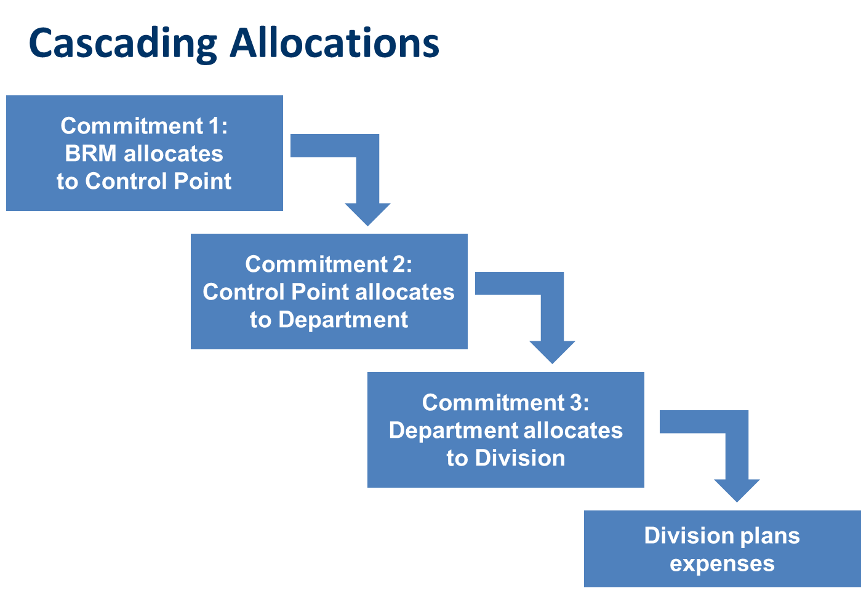
By creating cascading commitments, the UPlan system puts control over distributions in the hands of the planning units where such decisions are made. BRM will manage the planned distributions to control points, control points will manage distributions to departments, and departments will manage distributions to divisions and other sub-units. When adjustments need to be made, the planners at the appropriate level will make those adjustments.
In general, cascading commitments will be maintained for recurring allocations, but not for non-recurring allocations for specific purposes. In those cases, the commitment would indicate a planned transfer directly to the final target DeptID.
Finally, for actual financial transfers managed by Budget and Resource Management, such as transfers of State Educational Appropriations and Campus Core Funds, the cascading commitments will be used to transfer funds to their ultimate target DeptID. BRM will process transactions that transfer funds to the lowest level of the cascade.

Commitment Reports
Commitment Planning makes use of both types of reporting: form reports and Hyperion Financial Reports (FR). There are several reports related to the CmmtPlan application.

Commitment Form Reports
The Commitment Tracking module includes two form reports. They use the MyOrg POV feature to enable access to commitments across multiple DeptIDs.

By Source DeptID
This report displays all data elements for all commitments with Source DeptID values within a particular MyOrg selection.

By Target DeptID
This report displays all data elements for all commitments with Target DeptID values within a particular MyOrg selection.
These reports provide all information about commitments with a row for each existing distribution. To customize these reports, planners can export the reports to Excel and use Filters to select the specific types of commitments of interest.

Commitment Hyperion FR Reports (until Spring 2020)
Hyperion FR Reports also contains Commitment Tracking reports. You will find them by going to the HomePage > click on the Explore button > click on Commitment Reports directory. These reports are somewhat constrained because they will provide commitment data for only one Source DeptID or Target DeptID at a time.
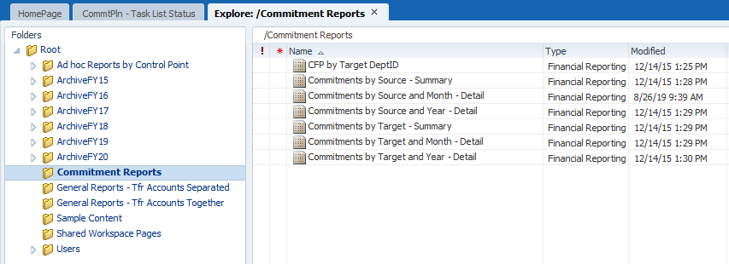

Following is a list of the Commitment Tracking reports with descriptions.
Report Title | Description
Commitments by Source - Summary | Summary of individual commitments provided by a particular DeptID and its children DeptIDs.; Detail by month for either the current year or next year and includes approved, unapproved, and "placeholder" commitments
Commitments by Source and Year – Detail | Details of individual commitments provided by a particular DeptID and its children DeptIDs.; shows YearTotal amounts for current year plus 10 years of commitments and includes approved, unapproved, and "placeholder" commitments
Commitments by Source and Month – Detail | Details of individual commitments provided by a particular DeptID and its children DeptIDs.; Detail by month for either the current year or next year and includes approved, unapproved, and "placeholder" commitments
Commitments by Target – Summary | Summary of individual commitments received by a particular DeptID and its children DeptIDs.; Detail by month for either the current year or next year and includes approved, unapproved, and "placeholder" commitments
Commitments by Target and Year – detail | Details of individual commitments that are received by a particular DeptID and its children DeptIDs.; shows YearTotal amounts for current year plus 10 years of commitments and includes approved, unapproved, and "placeholder" commitments
Commitments by Target and Month – Detail | Details of individual commitments received by a particular DeptID and its children DeptIDs.; Detail by month for either the current year or next year and includes approved, unapproved, and "placeholder" commitments
Here is an example of a Commitment report:
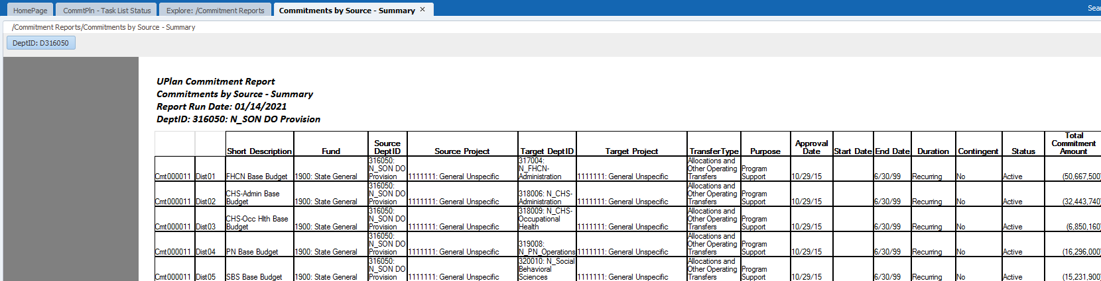
Note: In Commitment Reports, you may need to select Year in the POV. These reports use the format FY##. For example, FY21 is 2020-21; FY22 is 2021-22; and so on.

